 Unlocking the potential…

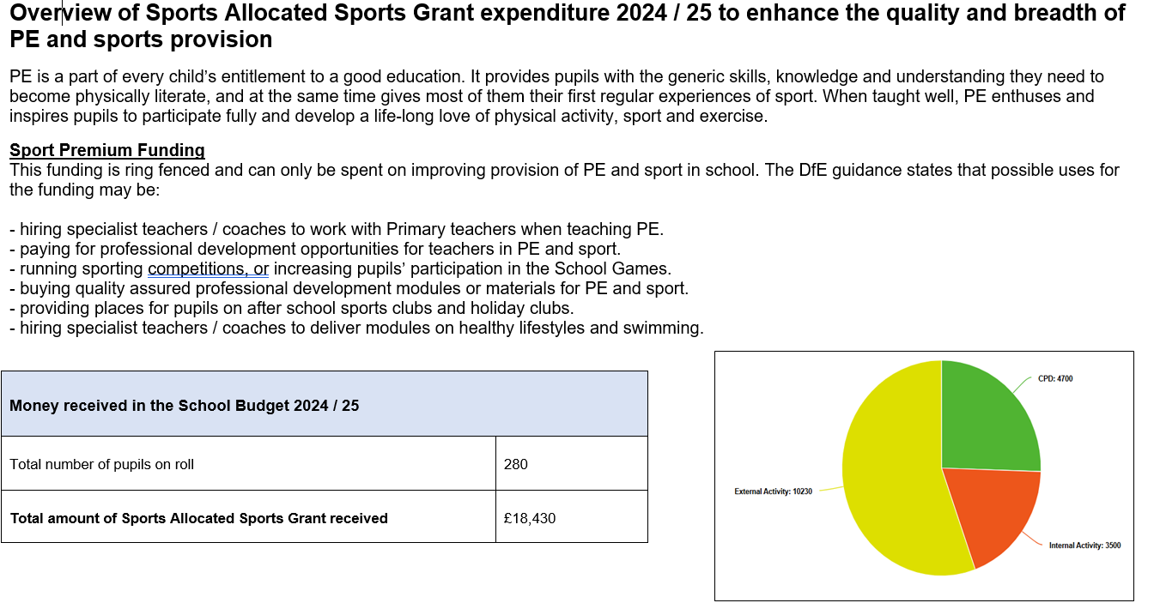
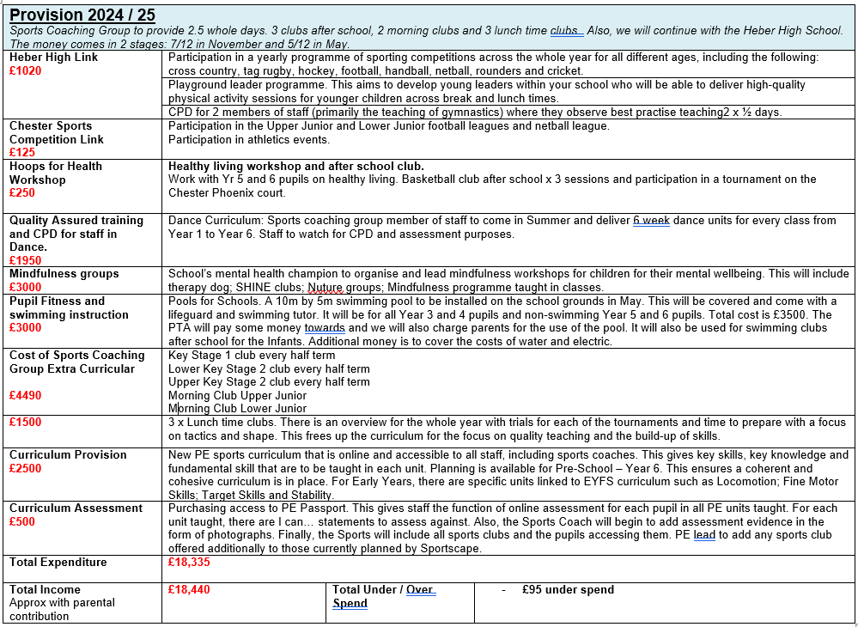

Meeting national curriculum requirements for swimming and water safety | 2024 | 2025
What percentage of our current Year 6 cohort swim competently, confidently and proficiently over a distance of at least 25 metres? | 82% | 95%
What percentage of our current Year 6 cohort use a range of strokes effectively? | 82% | 75%
What percentage of our current Year 6 cohort perform safe self-rescue in different water-based situations? | 82% | 75%
Can travel 10 metres on front and back | 14% | 5%
Can travel 5 metre on front and back | 4% | 0%
Did the school choose to use the Sport Premium to provide additional provision for swimming that was over and above the national curriculum requirements. Did we use it in this way? | Yes

Key Achievements to Date: | Areas for Development:
- All children across the school taught by sports coach at least once a week, including Pre School.  - 5 sports clubs weekly for the whole year.  - Participation in Heber inter schools’ tournaments for sports including cross country, rugby, football, hockey, rounders, netball, athletics, handball and cricket. Also part of Cheshire sports partnership and participate in football, cross country and athletics.  - Staff now have access to new curriculum materials using PE Passport scheme of work.  - Staff trained in the new curriculum and what a good PE lesson looks like: Warm up; teach new skill relating to game; practise the skill; learn the skill on the move; apply skill with a partner; use in small sided game; cool down.  - Clear overview in place for each Milestone which makes clear key skills and knowledge to be covered within each unit. It clearly links to the Rosenshine Principles.  - Aligned work of the school with Sports Coaching Group so to ensure same skills and knowledge covered.  - Long term planning includes OAA and Dance.  - Swimming: by using Pools for Schools, we could offer swimming to Year 5 and 6 pupils who haven’t achieved the curriculum, along with 5 x 45 minute sessions for Milestone 2 and a 2 week after school club sessions for Infant pupils.  - Purchased new resources and improved storage.  - Dance now consistently taught in all classes by a Dance teacher.  - Established a Sports Holiday Club led by Sports Coach employed by the school along with HAF funding so PP pupils can attend for free. | - Assessment to be clearer and completed at the end of each unit. Ensure it is evidence based with video / photographic evidence on PE Portal.  - Review school timetable and PE Overview to fit in additional 30 – 45 minute PE session led by Teacher so can explicitly teach Healthy lifestyles, Leadership, Yoga and OAA.  - Increase engagement with local community sporting opportunities such as archery, golf, tennis, martial arts and cricket.  - Participate in CSSA netball and rugby.

Academic Year: 2024-25 | Total fund allocated: £18,440 | Date Updated: August 2025
Key indicator 1: The engagement of all pupils in regular physical activity – Chief Medical Officer guidelines recommend that primary school children undertake at least 30 minutes of physical activity a day in school |  |  |  | Percentage of total allocation:
 |  |  |  | 33%
School focus with clarity on intended impact on pupils: | Actions to achieve: | Funding allocated: | Evidence and impact: | Sustainability and suggested next steps:
To ensure all pupils engage in good or outstanding physical activity across the week. | Plan for Sports coaches or PE lead to work with all classes across school.  Before and After school clubs available every week for the whole academic yea | £6115 | All observations of Sports Coaching Group coach no less than good. In a recent questionnaire  87% agreed they enjoyed attending and enjoyed sport clubs with 49% strongly agreeing.  OFSTED Jan 25, “Pupils develop their talents and interests through a range of extra-curricular clubs, including dodgeball” | Ensure more observations done of teaching staff using the scheme.  Units are available in the new curriculum that has been purchased – PE Passport. Ensure they are taught across school.
Key indicator 2: The profile of PE and sport being raised across the school through healthy lifestyle. |  |  |  | Percentage of total allocation:
 |  |  |  | 18%
School focus with clarity on intended impact on pupils: | Actions to achieve: | Funding allocated: | Evidence and impact: | Sustainability and suggested next steps:
To ensure the curriculum promotes a healthy lifestyle to pupils including healthy eating, physical exercise and healthy mind. | Mental health champion in school to lead mental health support groups and sessions to pupils including SHINE club; Timid tiger workshop; counselling; gardening club; anxiety gremlins.  Cheshire Phoenix basketball healthy lifestyle workshops. | £3250 | In the most recent pupil questionnaire, 96% of pupils said they agree that school helps them to lead a healthy lifestyle. 65% of the pupils strongly agreed. | Improve education on healthy lifestyle with regards to exercise and eating the right things through the use of PE Passport teaching units.  Implement Happy Mind scheme.

Key indicator 3: All staff have access to a high-quality Physical Education curriculum which ensures a cohesive and coherent teaching approach and evidence based assessment for each unit taught. |  |  |  |  |  |  |  |  | Percentage of total allocation:
 |  |  |  |  |  |  |  |  | 16%
School focus with clarity on intended  impact on pupils: | Actions to achieve: |  |  | Funding  allocated: |  |  | Evidence and impact: |  | Sustainability and suggested  next steps:
To ensure the pupils have access to a wide range of sporting activities that build in skills and knowledge across each of the Milestones and all pupils have access to the whole PE curriculum. | Purchase and implement new PE scheme – PE Portal.  Train staff in the use of the assessment which is aligned to the policy.  Clear pedagogical approach for the teaching of PE. |  |  | £3000 |  |  | See SOAP for PE Assessment across the whole school.  Whole school:  94% expected or better and 16% are assessed as depth.  FSM:  96% expected or better and 4% depth.  93% of pupils in a recent questionnaire said they enjoyed PE lessons and 71% strongly agreed. |  | Look at setting up an academic year calendar for additional sports clubs to given parental choice and increased warning.
Key indicator 4: Increased participation in competitive sport |  |  |  |  |  |  |  |  | Percentage of total allocation:
 |  |  |  |  |  |  |  |  | 6%
School focus with clarity on intended  impact on pupils:  To see increased participation in competitive sport across the whole school. | Actions to achieve:  Signed up to Heber agreement and send teams to all planned sporting events.  Signed up to Cheshire group which organise football and netball leagues and the hockey and rounders. |  |  | Funding  allocated:  £1145 |  |  | Evidence and impact:  Champions: Chester Schools Cross Country 1 gold, 2 silver, 1 bronze and Yr 4 Boys overall gold, Yr 5 Girls overall gold / Year 3 and 4 football Chester City tournament winners / Year 4 football Heber tournament winners / Year 4 football mini league winners / Cross Country Team event Year 5 and 6 Girls gold / Indoor athletics Year 3 and 4 Heber winners / Year 3 and 4 Heber Tag Rugby winners / Year 5 and 6 Heber Tag Rugby winners / Year 5 and 6 Heber Netball winners / Year 6 Heber Rounders winners  Runners Up: Chester Schools Cross Country team event overall runners up / Indoor athletics Year 5 and 6 Heber runners up / Year 4 Cheshire West football Bronze medalists / Year 5 and 6 Cheshire West football 4th place. |  | Sustainability and suggested  next steps:  Increase all girl teams in participation in competitive sports.  Girls netball team to participate in Cheshire events.  .
Key indicator 5: PE leader and all staff have high quality training for curriculum design and the teaching of PE. |  |  |  |  |  |  |  |  | Percentage of total allocation:
 |  |  |  |  |  |  |  |  | 11%
School focus with clarity on intended impact on pupils: |  | Actions to achieve: |  |  | Funding allocated: |  |  | Evidence and impact: | Sustainability and suggested  next steps:
To ensure all pupils have access to an outstanding PE curriculum which covers the national curriculum and that all teaching is at least good or outstanding. |  | Year 1 (previously a dance teacher) to teach Year 1 and Reception classes dance unit for staff to observe.  Sports coach (Dance specialist) to teach Yr 2 – Yr 6 a unit of Dance linked to topic for staff to observe and take away resources. |  |  | £1950 |  |  | All pupils from Reception to Year 6 will experience a unit of dance for their PE curriculum in the Summer term. | Do this for 2 years with a few for the staff to then have the resources and confidence to teach Dance moving forwards.
Key indicator 6: The pupils’ achievement in swimming improves with regard to the percentages achieving national curriculum requirements and improved strokes. |  |  |  |  |  |  |  |  | Percentage of total allocation:
 |  |  |  |  |  |  |  |  | 16%
School focus with clarity on intended impact on pupils: |  | Actions to achieve: | Funding allocated: |  |  | Evidence and impact: |  |  | Sustainability and suggested  next steps:
To ensure all Junior pupils have access to a high-quality swimming curriculum that covers the national curriculum and positively impacts on achievement in this subject area. |  | Booked swimming pool with Pools for Schools.  Constructed a timetable to ensure non swimmers in Milestone 3 are identified and given extra sessions.  Constructed a timetable for 5 lengthy sessions of 45 minutes.  Offered After school clubs for Infant pupils. | £3000 |  |  | Swimming instructor completes assessments on all pupils: See assessment sheets. |  |  | Look at PTA contribution and charging for sessions so sustainable.

