Home Learning due to isolation – WEEK 2
Milestone 1
Years 1 and 2
WEEKLY READING TASKS | WEEKLY SPELLING / PHONICS TASKS
Monday  Listen to the information video about caring for the environment. Discuss with your child after.  https://www.youtube.com/watch?v=V0lQ3ljjl40 | Monday  Year 1 – Phase 2/3/4 https://www.phonicsplay.co.uk/resources/phase/3/buried-treasure  Year 2 – Spelling Frame activity
Tuesday  Access Oxford Owls and read a story that has a woodland in. | Tuesday  Year 1 - https://www.phonicsplay.co.uk/resources/phase/3/pick-a-picture  Year 2 – Spelling Frame activity
Wednesday  Choose three words. Can you add the sound buttons onto them? | Wednesday  Sing the alphabet song https://www.youtube.com/watch?v=jYeMpUdufNk  Speed writing – choose 2 words from the Year 1 and 2 reading list. How many of these words can you write in 2 minutes?
Thursday  Find three facts about a woodland animal. | Thursday  Year 1 - http://www.ictgames.com/mobilePage/forestPhonics/index.html  Year 2 – Spelling Frame activity
Friday  What is the difference between a story about an animal and a factfile about an animal? | Friday  Year 1 – Study Ladder Spelling high frequency  Year 2 – Spelling Frame Test
WEEKLY WRITING TASKS | WEEKLY MATHS TASKS
Monday  Book of butterflies  https://www.literacyshed.com/butterflies.html  Watch the video. Talk about what happens when the butterflies come out of the book. Collect words/write a sentence to describe what happens. | Monday  Play hit the button number bonds:  https://www.topmarks.co.uk/maths-games/hit-the-button
Tuesday  Watch video Book of butterflies again  https://www.literacyshed.com/butterflies.html  Describe the room at the start. | Tuesday  How many groups of birds can you see outside your window?  Write number sentences to add the groups together.
Wednesday  What would you like to come out of a book? What might happen? E.g if a fish or tiger came out. | Wednesday  On a calendar, write down different family members birthdays or when special family events are.
Thursday  Draw a picture of your favourite animal and label it. | Thursday  Count all the animals you can find around your house. In pictures, toys, in the garden. Can you group them? Can you count them in groups of more than 1?
Friday  Write a short story about your favourite animal coming to visit your house. What do you do together? Do they get into any trouble? | Friday  Can you tell the time to the hour? Half an hour?  What time do you wake up? What time do you have lunch? What time do you go to bed?
LEARNING PROJECTS TO BE DONE THROUGHOUT THE WEEK
Theme – Where I live.

To develop knowledge of the location of significant places: Ask your child to look at where they live. What can they see outside the window in the front of their house? At the back of their house? What could they find near them? Find a map and see if they can find Chester. Do they know the name of their street? Can they create a street sign with their street name?

My address: Support your child to find out your address. Can they find the number on your door? Can they write the number in digits and words? Ask them to try writing the number using crayons and paint. Can they write a postcard or letter to a teacher at school? They could tell their teacher about where they live and things about their local area.

My house: Discuss with your child what their house looks like inside and outside? How many bedrooms does it have? Who has the biggest bedroom? Who has the smallest? Ask them to look outside their window and see if they can spot a house different to their own. Can they draw their house? How many windows at the front? How many windows at the back? Do you have one door or two? In a special bag - could you (with adult support) place things that make it your home? Why would you pick those items?

Draw a picture of your street. Support your child to take a look at the street and buildings around where they live. Encourage them to think about the shape of the buildings
STEM Learning Opportunities #sciencefromhome
Create a model of your street. What materials would be good to use for the different parts of the street?
Additional learning resources parents may wish to engage with
- Weekly homework – see your child’s class homework page on the school website
- Makaton sign of the week – https://www.makaton.org/
- Self-reflection plenary – see below
- Practise tying your shoe laces.

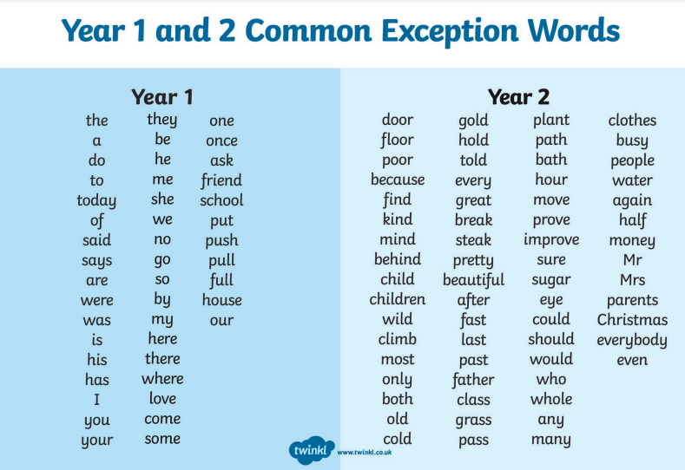

What superpower do you have? 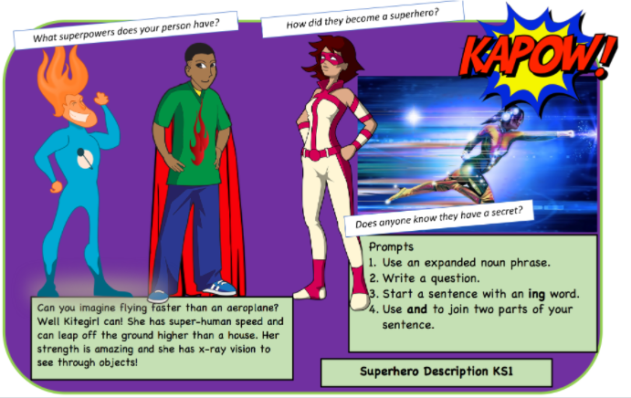

Comic Strip
