Island Adventures
Week 6: 6.11.20
By popular demand!!!!!
As requested, this week’s homework links to the wonderful zentangles you have been creating linked to ‘Leaf’.
Your task is to create something for your island using zentangle patterns. Some ideas are listed below:
- a flag
- a statue
- clothing
- a maze
- a design on the side of a building
Be as creative as you can.

I finished the zentangle we started in class and, as promised, I have copied it below. You may want to include some of the designs from it, the others you tried in class or even ones you have created yourself.
Have fun!

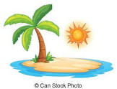
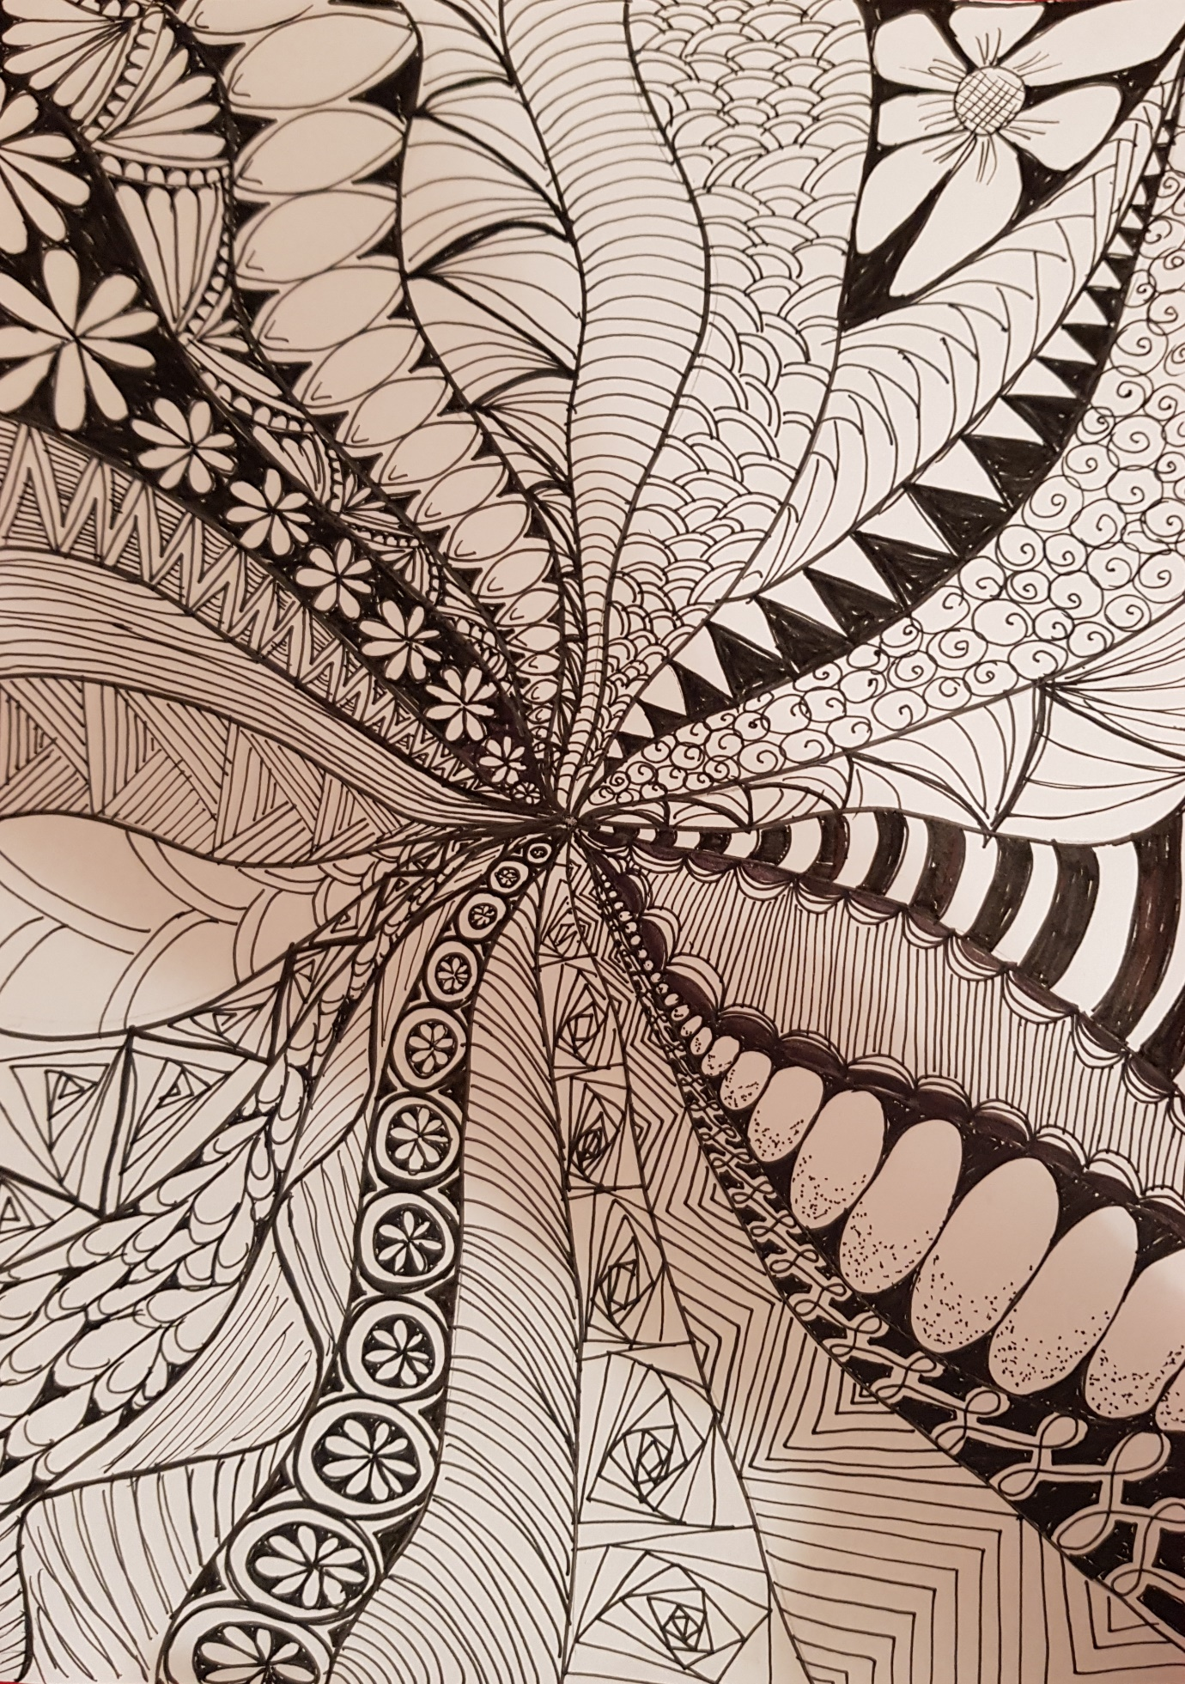
Create by Mrs McCarthy using the tutorial
https://www.youtube.com/watch?v=gBsW_wpFBxc

