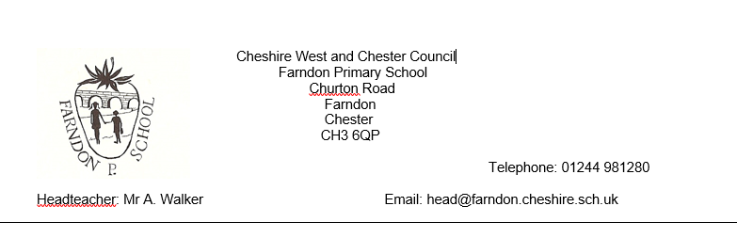
13th October 2020
Dear Parents/Carers,
What a busy few weeks we have had in school! It really does feel like a greater force is throwing all it can at us at the moment; from devastating flood damage to positive cases, we are getting hit from all sides.
All of this leads to a great deal of reflection on where we go next with our planned events and with our Parent Consultation day on the horizon we feel it would be prudent to postpone this until a later date.
Although we have no other staff with symptoms, we do have a number self-isolating as a precautionary measure after being in contact with staff who have tested positive. By keeping them at home, we lower the risk of them developing symptoms in school and therefore closing down another bubble. Because of this, we do have a number of staff who will not be in school on 23rd October.
With our desire to minimise the number of people entering our school site and the fact that many staff will be isolating, we feel that the wisest course of action is to postpone.
We cannot apologise for the disruption and at this point are unable to predict when a new date for consultations will be set. We will of course let you know when we have a better idea and look forward to sharing your child’s successes with you in the future.

Kind regards

Sarah Wakefield

