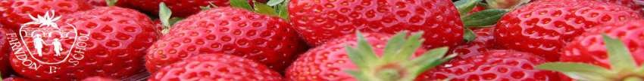

Home Learning due to isolation – WEEK 2
EYFS
Reception
WEEKLY READING TASKS | WEEKLY PHONICS TASKS
Monday  Read the book by Alison Bartlett and Vivian French called “Oliver’s Vegetables.” If you don’t have a copy you can listen to the book here :  https://www.youtube.com/watch?v=2yvllKqyVUc | Monday  Daily phonics - Practice the sounds your child is working on and blend words. This can be oral blending (e.g. spoken out loud c-a-t) or written if appropriate. Interactive games found on link below. https://www.phonicsplay.co.uk/
Tuesday  Reception age children: Children to read to parents daily. Visit Oxford Owl for free eBooks that link to your child’s level. You can create a free account at: https://www.oxfordowl.co.uk/for-home/ Complete the linked Play activities for each book. | Tuesday  Play I-spy with things you can see out of the window. You could alternate between the initial sound in the word e.g. “I spy with my little eye something beginning with t”. Or with oral blending e.g. “I spy with my little eye a t-r-ee”
Wednesday  With your child, look in magazines, newspapers and books for the tricky words they are currently learning. They could use a highlighter to highlight in magazines and newspapers. | Wednesday  Play a listening game- Gather a selection of objects that make sounds from around the house. Cover your child’s eyes with a blindfold and make sounds with the objects collected. Can they figure out what the object is without looking at it?
Thursday  Look at recipe books and food magazines. Encourage your child to use their phonics knowledge to decode the ingredients list. Select a recipe and make this together. ( or try making Oliver’s Soup!) Encourage your child to read the labels on packaging to figure out which ingredient it is. | Thursday  Daily phonics - Practice the sounds your child is working on and blend words. This can be oral blending (e.g. spoken out loud c-a-t) or written if appropriate. Interactive games
Friday  Use the Small Talk website for ideas on supporting your child’s Communication and Language development. | Friday  Play ‘I Spy’ but focus on different fruits and vegetables. Take turns to choose and guess the right one !
WEEKLY WRITING TASKS | WEEKLY MATHS TASKS
Monday  Write a food diary for the week ahead – for each day can you list the fruit and vegetables? Could you do it as a picture diary? | Monday  Sorting Healthy/Unhealthy food. Vegetable printing, pattern making and Andy Goldsworthy  https://wrm-13b48.kxcdn.com/wp-content/uploads/2020/06/Day-1-Olivers-Vegetables.pdf
Tuesday  Oliver tries new vegetables in the story, which ones have you tried already? Are there any you haven’t? You could write about why you do/ do not like each one. Eg. I like peas. I do not like leeks. | Tuesday  I went to the Supermarket and bought........ Counting activities  https://wrm-13b48.kxcdn.com/wp-content/uploads/2020/06/Day-2-Olivers-Vegetables.pdf
Wednesday  Can you pick a vegetable that you don’t know anything about and research where it comes from and how it is grown? Maybe you could write a fact book about it with pictures. | Wednesday  Missing number addition / Guess my rule sorting  https://wrm-13b48.kxcdn.com/wp-content/uploads/2020/06/Day-3-Olivers-Vegetables.pdf
Thursday  Which is your favourite vegetable? With the help of a grown up can you write a recipe using the vegetable? We could share them and other people at school could have a go at making it! | Thursday  Counting and Kitchen Disco!  https://wrm-13b48.kxcdn.com/wp-content/uploads/2020/06/Day-4-Olivers-Vegetables.pdf
Friday  Chose a vegetable or fruit you haven’t ever tried before – be brave and try it! Can you then describe how it looks, tastes, smells, feels like? An adult can write down your ideas or you can! | Friday  Measuring and making MilkShakes  https://wrm-13b48.kxcdn.com/wp-content/uploads/2020/06/Day-5-Olivers-Vegetables.pdf
LEARNING PROJECTS TO BE DONE THROUGHOUT THE WEEK
- Look at the different vegetables and fruit in your home, can you put them into different categories? Which have seeds / which are grown underground / which grow on trees / which are a similar shape? Think of your own categories too!
- Where in the world are your fruit and vegetables typically grown? Which countries in the world do bananas/pineapples/mangoes grow best? Can you find the places on a map?
- Think about the different things the vegetable needs to grow – can you list them?
- Have a go at making Oliver’s Vegetable Soup – with a grown up ! See recipe below.

STEM Learning Opportunities #sciencefromhome
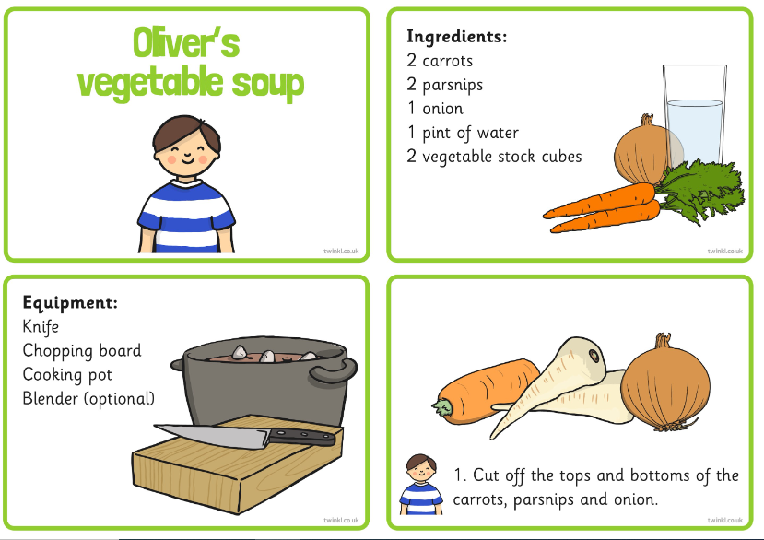
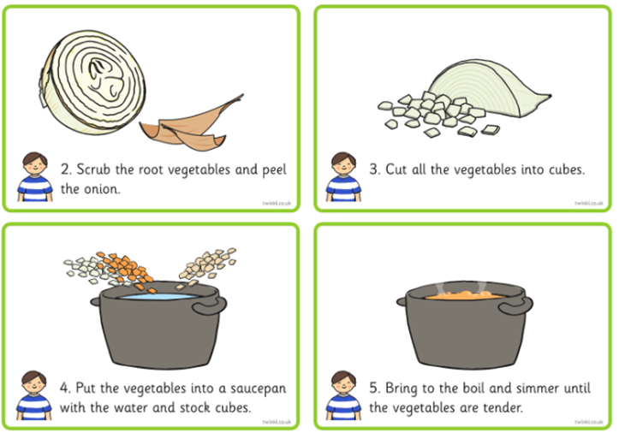

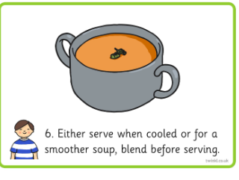

Additional learning resources parents may wish to engage with
See links in Maths Tasks which have lots of extra activities linked to Oliver’

