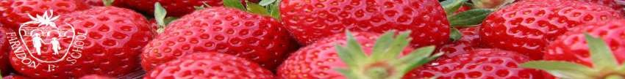

Home Learning due to isolation – WEEK 1
Milestone 2
Years 3 and 4
WEEKLY READING TASKS | WEEKLY SPELLING TASKS
Monday Read a fiction book for 20 to 30 minutes. Play the dice game below and answer the questions. | Monday Spelling Frame for 30 minutes.
Tuesday Read your fiction book again for 20 to 30 minutes. Answer 2 questions from 3 of the boxes on the reading questions bookmark. | Tuesday Complete a SpaG Mat. Make sure you complete the correct one for your year group.
Wednesday Today choose a non-fiction book to read for 20 to 30 minutes. Roll the Non-fiction dice 3 times and answer the questions. Write the answers down if you can. | Wednesday Spelling Frame for 30 minutes.
Thursday Read your fiction book for 20 to 30 minutes. Play the dice game again but write your answers down this time if you didn’t on Monday. | Thursday Complete a SpaG Mat. Make sure you complete the correct one for your year group.
Friday Read either a fiction OR a non-fiction book for 20 to 30 minutes. Complete the book review sheet. You can write a book review about the book you have just been reading or about another book that you have enjoyed in the past. | Friday Spelling Frame for 30 minutes.
WEEKLY WRITING TASKS | WEEKLY MATHS TASKS
Monday – Setting Description  Write a setting description of the Chocolate Factory from Charlie and the Chocolate Factory. To help with your ideas, you could watch a clip from the film, or use the images below! Remember to describe your senses when writing. Use the senses planning frame below to help you with your word choices! | Monday – Roman Numeral Clocks  Complete the sheets below on telling the time on a Roman Numeral Clock. You will need to write down what time is being shown on the clock and also complete the clocks to match the time written below it. Challenge: Could you draw some of your own clocks which show 5 to the hour, 5 past the hour, 20 past the hour and 25 to the hour?
Tuesday – Non-Chronological Report  Research facts about your favourite animal and write a non-chronological report about them. Use the planning frame to help with your research. Remember to find out about the appearance, habitat, diet and if/why they are endangered. Why not try to draw a picture of your chosen animal after you have written your report? | Tuesday – Ordering Numbers  Complete the sheet below. Order the numbers correctly to find the answer to the jokes. Challenge: Can you create your own joke in the same style so the person solving it needs to order the numbers you give to reveal the answer?
Wednesday – Instructions  Write a set of instructions on how to make or bake something. Perhaps you know how to bake a cake or how to make your favourite dinner? Don’t forget to include the list of equipment you need and your step by step instructions. Have a go at the imperative verb activity below to help you before you write your instructions. | Wednesday – Estimating Number Line Challenge  Draw a line. At one end write 0 and at the other end write either 1000 or 10,000. Roll a dice either 3 times to create a 3-digit number if you are using the number line to 1000 or roll the dice 4 times to create a 4-digit number if your number line goes up to 10,000. Now mark on your number line where you estimate the numbers to go. Continue this with more numbers. What numbers might you want to add to your number line first to make your task easier?
Thursday – Diary  Write a diary entry about a day you have enjoyed recently. Remember to include thoughts and feelings and the main events that you enjoyed. | Thursday – Measuring  Using the measuring table below, choose a range of different items in your house and measure them using cm. Can you then convert these measurements to mm? Can you also convert them to m? You may want to do some research first into mm, cm and m find out the different equivalents.
Friday - Dialogue  Watch the short animation ‘For the Birds’ on the Literacy Shed. Think about the dialogue that would take place between the birds during this animation. Complete the speech bubbles using the activity sheet below and then write a piece of dialogue between the birds, adding speech marks around what has been said. | Friday – Pounds and Pence  Have a go at the money worksheets below. Can you work out which coins you will need to buy certain items? Challenge: look on an online shopping websites and see if you can work out which notes and coins you will need to buy certain items.
LEARNING PROJECTS TO BE DONE THROUGHOUT THE WEEK
History
Create your own PowerPoint about the Stone Age.
Remember to do a title page first and plan what each section will be about.

Think about these questions to help you decide what to write about.
What did they wear?
What food did they eat?
What were their homes like?
What do you know about the Mesolithic, Palaeolithic and Neolithic age?
What do you know about cave paintings?
If you have anything else that you can think of, then add that too.

Art
Look online and find some examples of cave paintings. Can you create your own cave painting picture?

STEM Learning Opportunities #sciencefromhome
Activity 1: Have a look at the page below on ‘Making a Lava Lamp’. Have a go at making your very own Lava lamp at home, it is so easy! Have a read of the science behind it at the bottom to discover what is happening.

Activity 2: Could you conduct some research to find examples of Igneous Rocks, Sedimentary Rocks and Metamorphic Rocks. You could create your own fact file leaflet about these 3 different types of rocks. Can you also explain how each of the different rocks are formed? You can also use the knowledge of what you have already learnt in school.
Additional learning resources parents may wish to engage with
BBC Bitesize
Ensure homework for the week is completed from the school website.
Times Table Rockstars
Spelling Frame
Oak National Academy

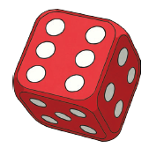

- Read your book either to yourself or out aloud to someone else.
- Roll the dice and read the matching question or instruction.
- Talk to the other person about your answer / Write down your answer.
- Roll the dice twice more and answer those questions too.
If you don’t have a dice, you could put numbers one to six on separate pieces of paper into a pot and pull one out to get your number.
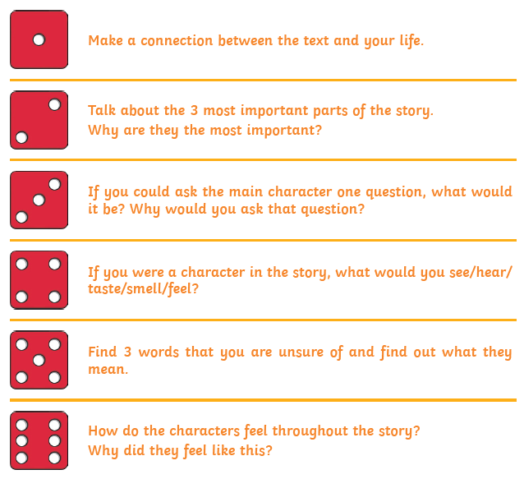

Non-Fiction Dice
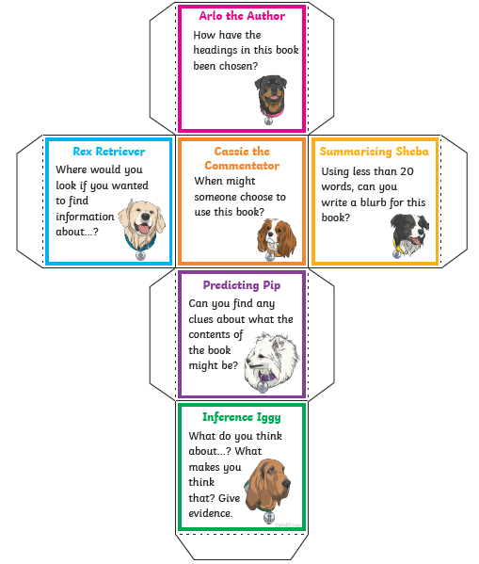

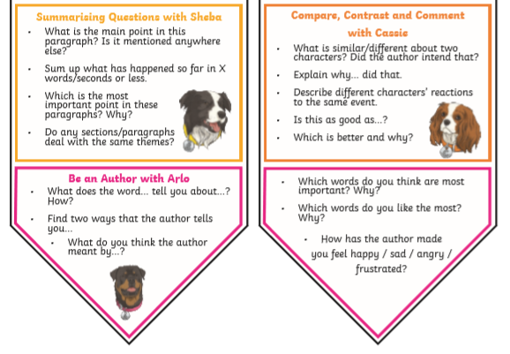
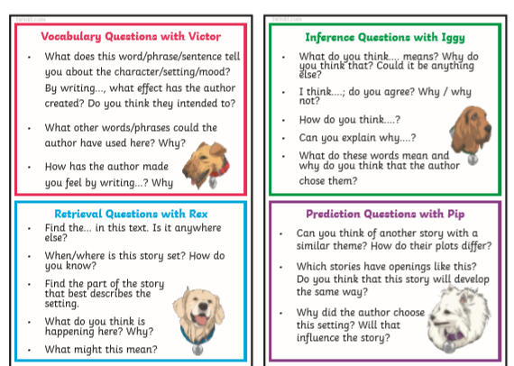
Reading Bookmark
Book Review
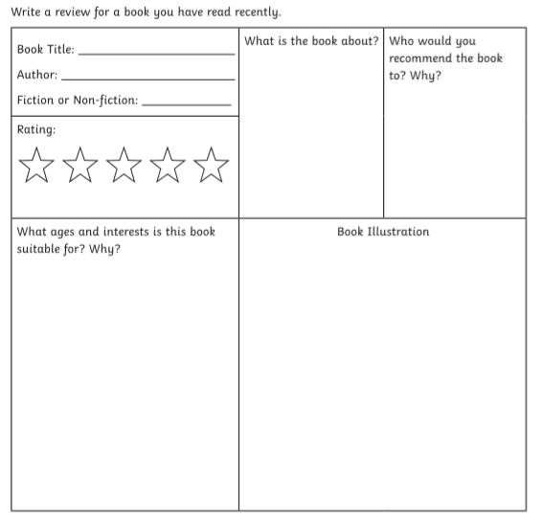

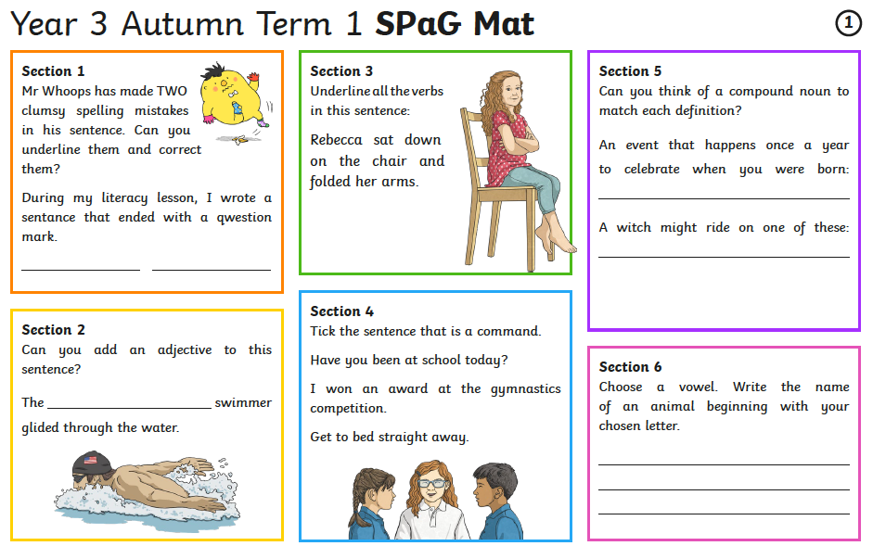
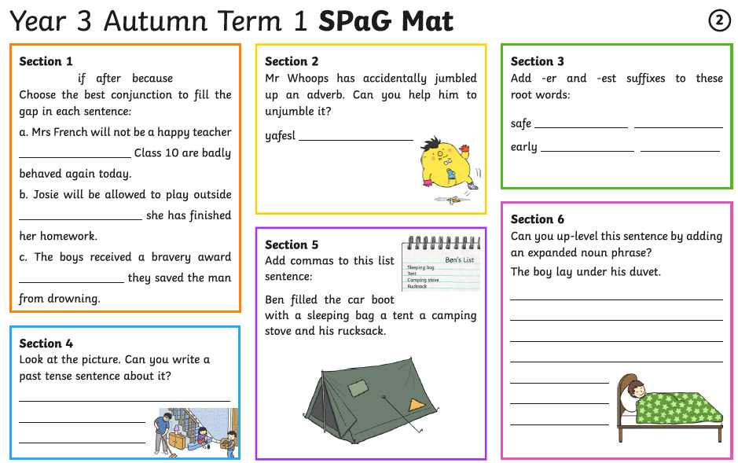
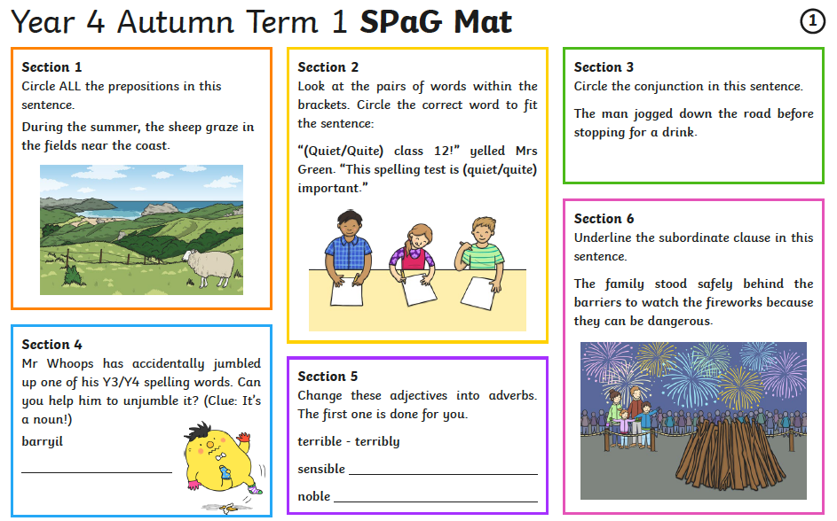
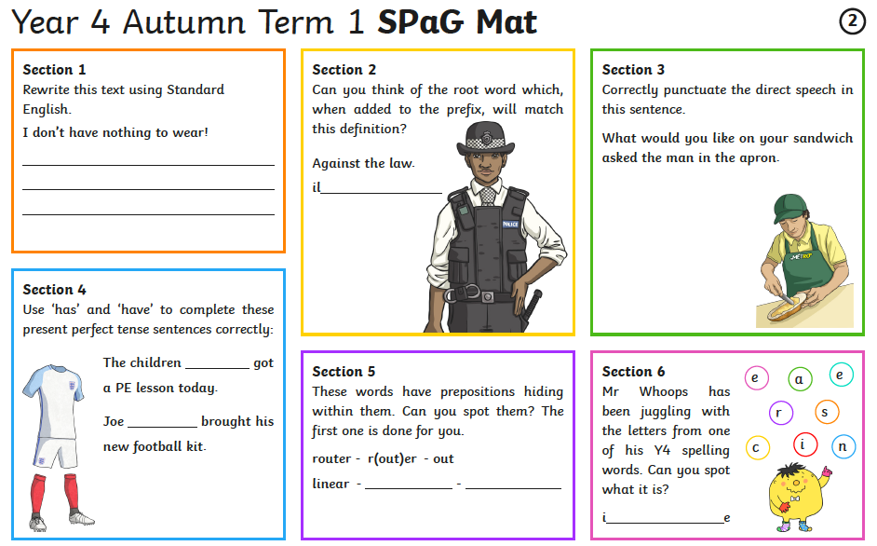
The Chocolate Factory – Setting description
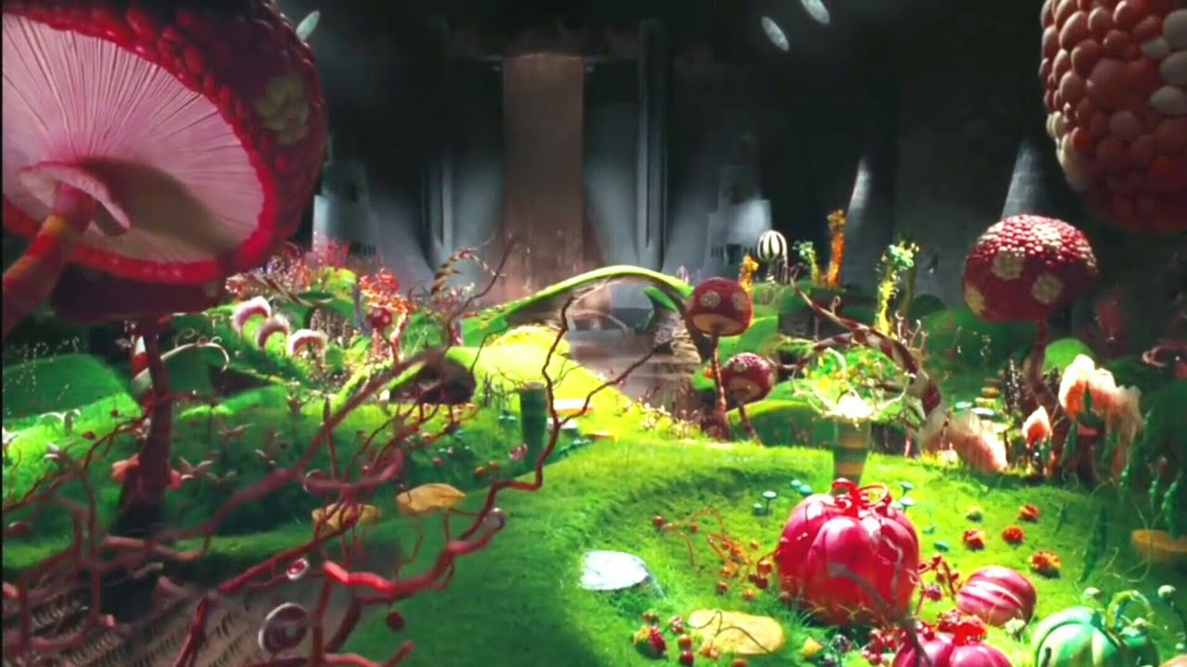

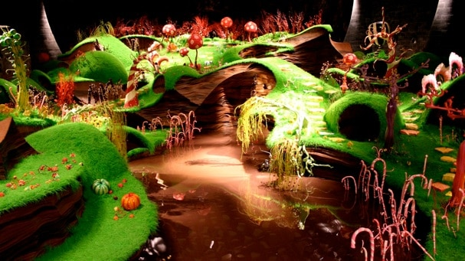

Senses planning frame

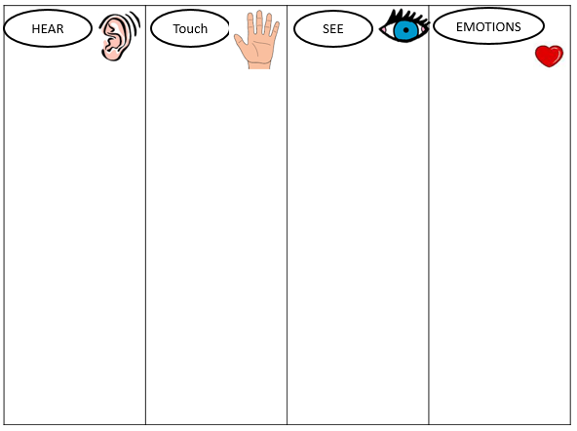

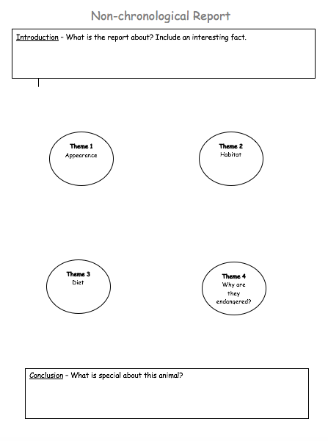

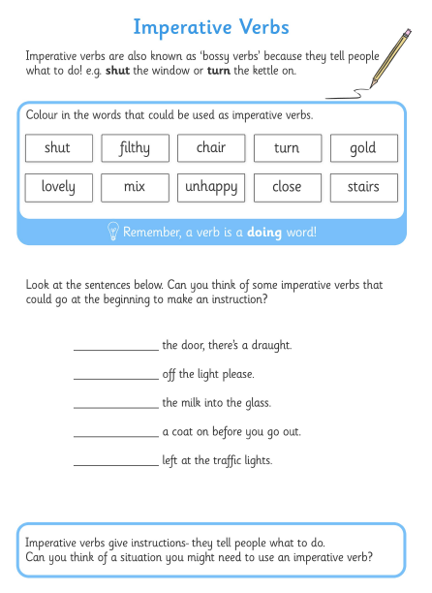
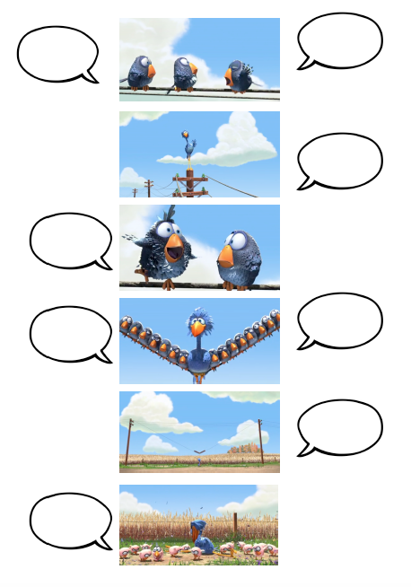
For the Birds – Dialogue writing
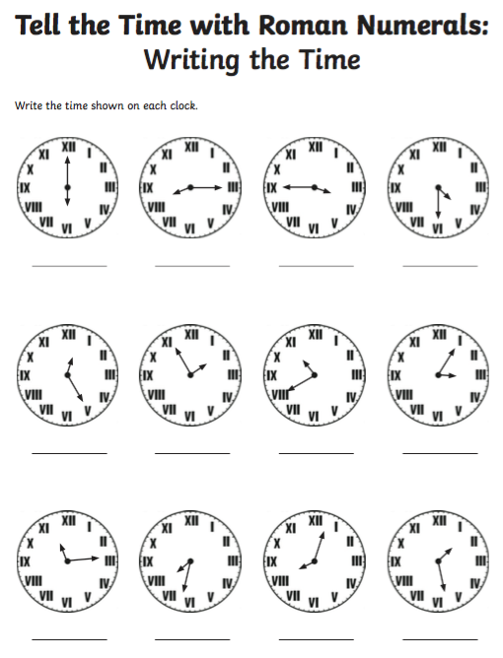
Telling the time – Monday Activity
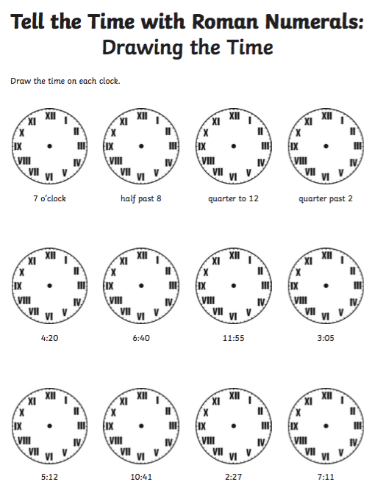
Telling the time – Monday Activity
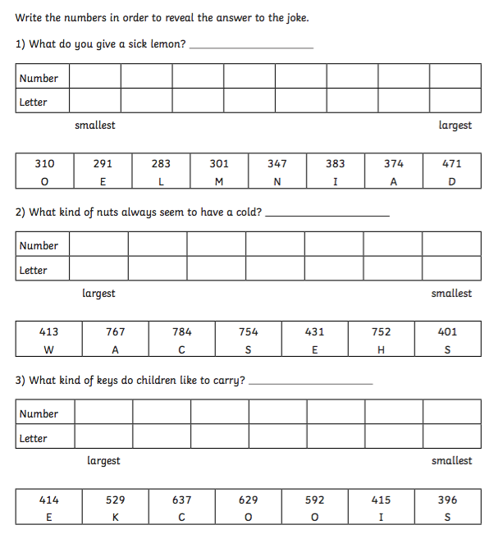
Ordering Numbers – Tuesday Activity
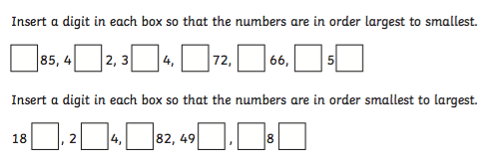

Measuring – Thursday Activity

Name of Item | CM | MM | M

Pounds and Pence – Friday Activity
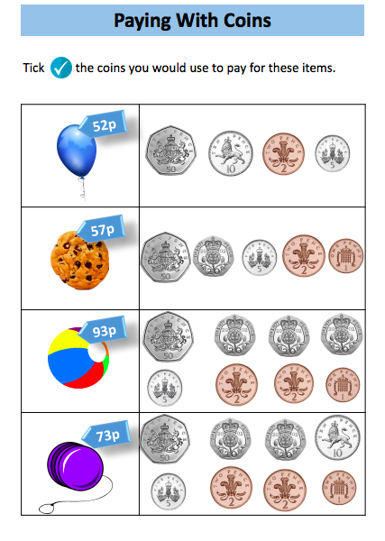

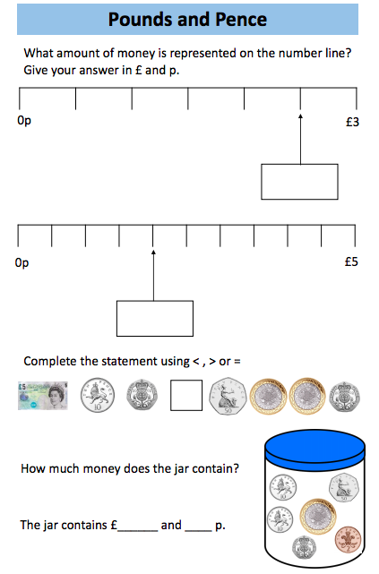
Pounds and Pence – Friday Activity
