Farndon Primary School  Student Newspaper | 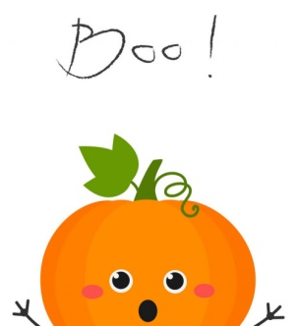  ^{The}FPS  newspaper
Autumn 2021 | Editor and Chiefs:  Ava, Dylan, Emily and Thomas |  |  | Issue: 20
Hello Farndon Primary School!

It's been a while since the newspapers have been out, but now it's time for a spooky update…

We have the spookiest recipes to the funniest jokes that make you burst with laughter. So we hope you will have the best year at Farndon!

We will try to provide you with spectacular activities to fiddle with no matter if you're at home or at school.

Our favourite thing to do at Halloween is to go trick or treating with my friends in the craziest costumes or maybe even go to a haunted house. But except for scary costumes this is all just for fun to celebrate our favourite time of year.

HAPPY HALLOWEEN!!!

 |  | ARTICLE 12, 13, 14, 15 & 31 | Saying of the month: Have a spooky half term.
Origami
Origami Bat!
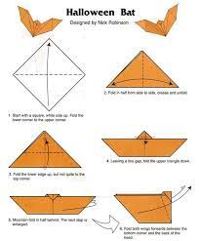

Instructions!
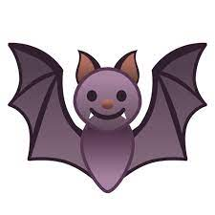
Step 1: Make a square with the piece of paper.
Step 2: Fold the piece of paper into a triangle.
Step 3: From the base fold it over.
Step 4: It will now look like a boat.
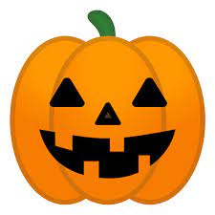
Step 5: The tiny triangle at the top you bend it so it turns into a head.
Step 6: Put eyes on it and colour it in!!

Enjoy!!

Puzzles, Conundrums and things to amuse!
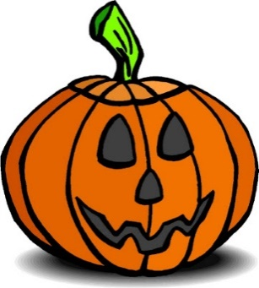
Junior Safety Officers
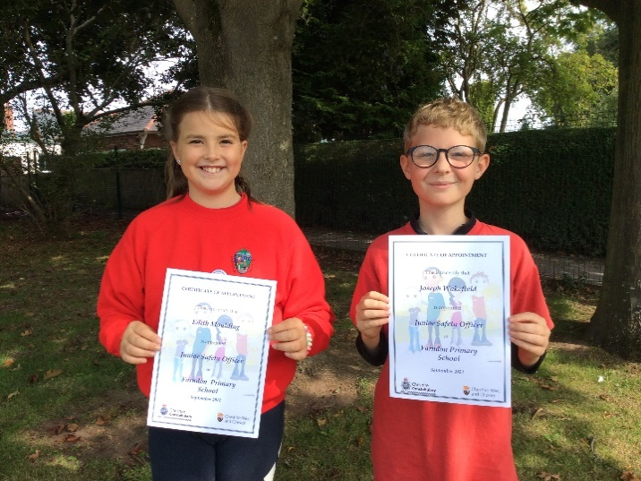
Hi Farndon School, our names are Edith and Joseph and we are the new Junior Safety Officers (JSO’s)
Watch out for our termly competitions.

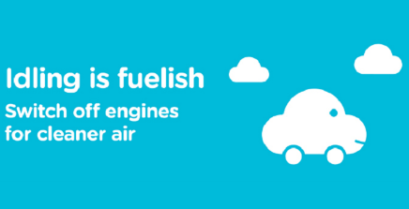
Our focus for September was Be a Breath of Fresh Air. This month’s topic is all about Clean Air and there are two ways that you can help. The first is this; if you come to school in a car please ask the person who brings you and collects you all about Engine Idling. This is when a car is stopped for over a minute but the engine is still running. It produces Carbon Emissions which are bad for us and the environment, so please ask them to turn the engine off. This will help improve the air quality around our school, making it safer and healthier for everyone.
The second is to try and walk, scoot or cycle to school, even if it’s just part of the way. This will help improve the air quality around our school, making it safer and healthier for everyone.

Our first focus for October was Be Bright, Be Seen. You will have noticed that it gets darker outside earlier than it did over summer. If we’re out and about, drivers may not be able to see us easily, especially if we’re in dark clothes like our uniforms. But never fear!
Junior Safety Officers
We have some ideas on how you can make sure you’re seen. You could bling your bag, coat and bike by adding bright colours, bright reflective stickers and keyrings or extra lights. Also make sure your helmet is bright and can be seen.
Do you know the difference between reflective and fluorescent? Fluorescent is best in the day time as the colours react with the suns UV rays to make them seem much brighter. Reflective is best at night time as the light from the traffic headlights will bounce back of the reflective material and shine brightly meaning you are more likely to be seen This will be very important soon as it will be Halloween and many of the costumes are quite dark.
Remember Fluorescent for Day, Reflective for Night.

Our second focus this month is Halloween and Bonfire Night Safety
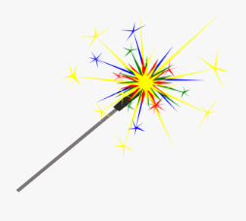
It’s not long now until Halloween and Bonfire Night and many of us like to get dressed up and we will be going to see a fireworks display and Sparklers can be great fun, but did you know a sparkler can reach 2000 Degrees?, that’s 20 times hotter than boiling water. Used sparklers are still hot when they have gone out so never pick them up. Here are some ways to keep safe when you go Trick or Treating or go to a bonfire and firework display.
You could carry a torch or use the light on a mobile phone. Always stand well back from a bonfire and never go back to a lit firework.

We hope you enjoyed our competitions and Bright Day.

Thanks for reading everyone!🤗🚦

Be Safe, Be Seen, Be Secure.
Recipe
How to make Dracula Dentures
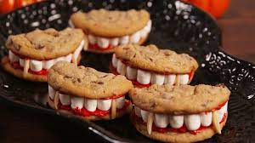
Ingredients
- 10 freshly baked chocolate chip cookies
- A bag of mini marshmallows
- 200g Icing sugar
- 100ml of water
- 1 teaspoon of red food colouring.
- Almond flakes
Instructions
- Start by baking 10 chocolate chip cookies then wait 5 minutes and cut them in half.
- Once they have cooled, make the red icing by mixing 200g of icing sugar and 100g of warm water and as much red food colouring as you think it will need to look like gums.
- Put red icing on the bottom of the cookie and put the marshmallows on it. Put some icing on our other cookie half and stick together.
- Finally cut the almond flakes in half and stick them in between the marshmallows like in the picture.

Craft
How to carve pumpkin!

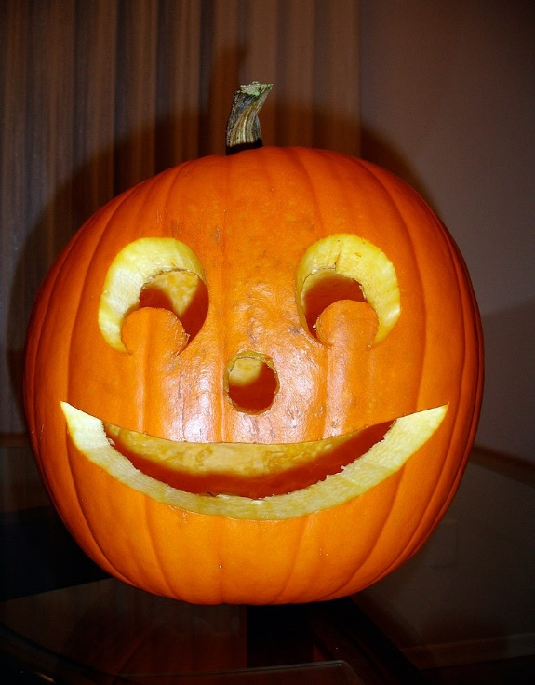
- First, choose a large pumpkin and use a sharp serrated knife and cut off the crown. Also get any family member to help!!!!
- Next, use a large serving spoon, scoop out the seeds and fibres and discard. Then remove some of the flesh.
- With a marker pen, draw a simple outline of a face on the pumpkin.
- Use a small serrated knife to cut out the eyes, nose and mouth. Always cut away from you in case the knife splits!!!
- Pop a tea light inside the pumpkin, light it and replace the crown.

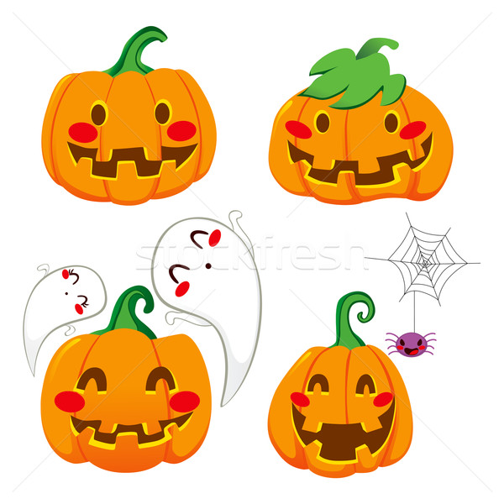
Have a happy Halloween, have a pumpkin Halloween!!!
BY Freya

Craft
How to make Halloween slime!
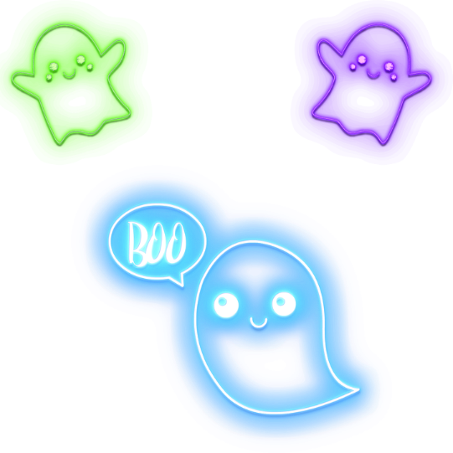
You will need
- Glue
- Baking Soda
- Glitter
- Contact Lens Solution

- Firstly, squeeze 5 oz. glue into a bowl.
- Next, add 1 tea spoon of baking soda.
- Then add glitter paint starting with a small amount until you reach desired colour.
- Stir, until combined then mix in 3 teaspoons of lens solutions.
- Roll slime in your hands until no longer sticks this can take a whole 5 minutes.
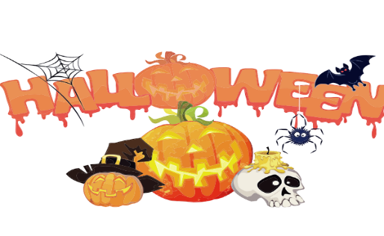
- Finally add eyes and your good to goo!

Happy Halloween by Ariana Year 6

Craft
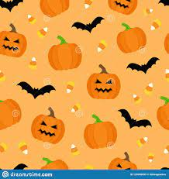
Halloween Crafts for Infants
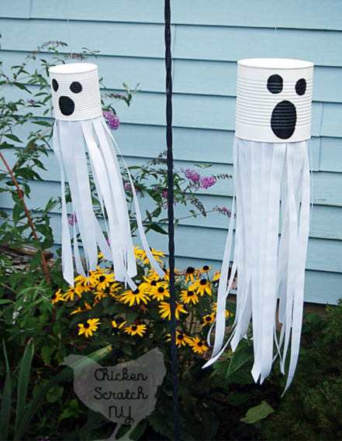

Instructions:
First get a white tin and draw two
eyes and a mouth in a permanent black
pen.
Then cut 30 long strips of paper or
tissue paper (paper is our preferred
option) and stick them on the inside
of the tin.

VOILA! THERE YOU HAVE A GHOST!
By Jasmine and Harriet

Infant Competition
For this competition you must colour this haunted house in.

You must then hand it to your teacher and there will be three winners who get a spooky surprise.

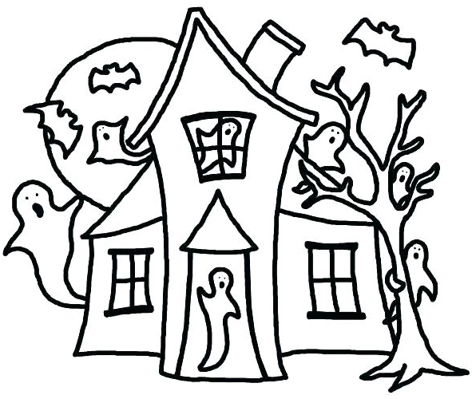

Name:___________________
Class:____________________
Junior Competition
Junior competition!!
This addition is based on Halloween. We want you to colour in this pumpkin and you might win a prize!
GOOD LUCK by Ava & Harvey
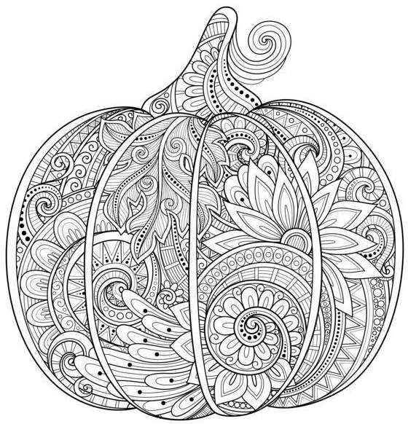
Name:_____________
Class: ____________

This needs to be returned to your teacher by Thursday 21st of October 2021. Winners will be picked when we return to school.
Achievements
Tag Rugby

First game was a 2-1 win against Tattenhall. Thomas and Finn scored tries.
In our next game it was a smashing 5-0 win with most of the squad getting a try.
Farndon made it into the semi’s and won 5-0 once again vs Shocklach with Jamie, Tom (x2), Finn and Rhys all scoring. In the finals it was a tight game but Finn got us 1-0 up a few minutes later Tattenhall B scored a try to equalize it. Then it went to last try wins and sadly Tattenhall pulled a try and won. Our top scores were Tom with 5, Finn with 3 and Jamie with 2.
We want to say a huge well done to everyone who took part in this very intense tournament.
Top taggers were Dylan, Alexis and Freya.
Other News
- Dylan scored a hat trick on his debut for an academy.
- Dylan won a swimming competition for Wrexham.
- Allegra got rewards from stagecoach.
- Rhys won a county tournament in tennis.
- Leo H moved swimming groups super quickly!
Farndon PS also came first in cross country so well done to them!

