Art Curriculum Milestone 3
Topic | Key Vocabulary | Sticky Facts |  |  | Essential Skills
Child Of Our Time  Printing  Artist:  William Morris | Relief printing Lino printing  Mono printing  Resist printing  Pattern  Repetition  Symmetry  Layering  Material  Effect  Wax resist | - William Morris was an English textile designer, poet and novelist.  - His drawings and textile prints were based on nature and included flowers and leaves  - His work included wallpaper design and print, furniture, stained glass windows, tiles and tapestries.  - Relief printing is created by removing areas of a block to form a pattern, usually this is carved from the block. An example of relief print is lino or block printing.  - In lino printing, a design is cut into the lino surface with a sharp knife, the lino sheet is inked with a roller, and then impressed onto paper or fabric.  - Mono printing is a form of printmaking made from a block that can be reprinted. Unlike other forms of printmaking mono print uses a shape, line or image made into the block that can only be printed using one colour.  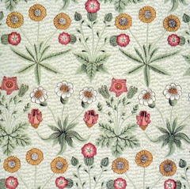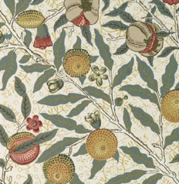 |  |  | - Create a print design in the style of William Morris.  - Explain a few techniques including the use of relief, mono and resist printing.  - Choose the printing method appropriate to the task.  - Build up layers and colours/textures.  - Organise their work in terms of pattern, repetition, symmetry or random printing styles.  - Be familiar with layering prints.  - Be confident with printing on fabric and paper.  - Alter and modify work.  - Work relatively independently.
Walk Like An Egyptian

Endangered  Sculpture:  Sustainable materials  Artist:  Jill Townsley/  Michelle Reader | Modelling  Sculpture  Recycled  Natural  Man-made  Construction  Sustainable | - Jill Townsley is a British artist who is most famous for her sculptures and installations.  - She uses materials that are common and everyday, such as staples, plastic spoons, bristles, plastic balls, brass wire, fishing wire and polystyrene beads.  - Michelle Reader reuses waste materials to create unique figurative sculptures.  - She reuses household and industrial waste in her work, combined with found objects from charity shops and scrapyards.  - Sculpture is the creation of artistic objects in three dimensions.  - Sculpture is a work of art that is produced by carving or shaping materials.  - A sculpture may look exactly like a person or object or may reflect shapes and forms that the artist invents. |  |  | - Design and create a sculpture using sustainable materials.  - Describe the different qualities involved in modelling, sculpture and construction.  - Plan a sculpture through drawing and other preparatory work.  - Create sculpture and constructions with increasing independence.
Traders and Raiders  Collage, Printing and Drawing | Value  Shade  Tint  Relief printing  Line  Tone  Pattern  Texture  Form  Space  Colour  Shape | - Value is the lightness or darkness of a colour. High value is light, and low value is dark.  - We can create value with a range of pencil techniques.  - A shade is a darker version of a colour.  - A tint is a lighter version of a colour.  - Relief printing is created by removing areas of a block to form a pattern, usually this is carved from the block. An example of relief print is lino or block printing. |  |  | - Create Viking art using collage, printing and drawing.  - Explore the properties of visual elements, line, tone, pattern, texture, colour and shape.  - Demonstrate a wide variety of ways to make different marks with dry and wet media.  - Explain a few printing techniques including the use of relief, mono and resist printing.  - Choose the printing method appropriate to the task.  - Build up layers and colours/textures.  - Be confident with printing on fabric and paper.  - Identify artists who have worked in a similar way.  - Develop ideas using different mixed media using a sketchbook.  - Alter and modify work.
Out of this World  Sculpture  Clay alien eyes | Sculpture  Modelling  Clay  Malleable  Texture  Relief  Slabs  Coils  Slips  Mould | - Sculpture is a work of art that is produced by carving or shaping materials such as stone or clay.  - Clay is a naturally occurring, sticky fine-grained earth. It can be moulded into different shapes when wet.  - Clay is used to make bricks, potteries, and ceramics. It is also used to make sculptures and decorative patterns and designs.  - Clay is malleable which means it is capable of being shaped or formed, whether by hand or with tools.  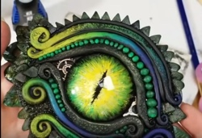  - Texture refers to the tactile quality of an object's surface.  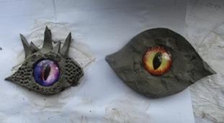  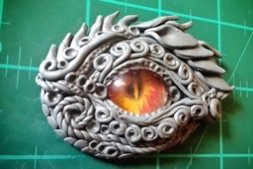  - Relief is a sculptural technique where the sculpted elements remain attached to a solid background of the same material. |  |  | - Design and create an alien eye out of clay.  - Describe the different qualities involved in modelling, sculpture and construction.  - Use recycled, natural and man-made materials to create sculpture.  - Plan a sculpture through drawing and other preparatory work.  - Develop skills in using clay including; slabs, coils, slips etc.  - Create sculpture and constructions with increasing independence.
Let Me Entertain You  Drawing and Painting  Artist:  Andy Warhol | Pop Art  Line  Tone  Pattern  Colour  Shape  Primary colours  Secondary colours  Complementary colours  Shade  Tint | - Andy Warhol was an American artist.  - Warhol was called a ‘Pop Artist’ because he took images from popular culture, or everyday life.  - He famously created portraits of stars such as Marilyn Monroe and Elvis Presley. He made numerous portraits of the same person using different bright colours for each picture.  - He worked with many forms of media, including: painting, printmaking, photography, drawing and sculpture.  - Primary colours are the three main colours (red, yellow and blue).  - Secondary colours are made by mixing two primary colours.  - Complementary colours are opposite to each other on the colour wheel.  - A shade is when you add black to a colour to make it darker.  - A tint is when you add white to a colour to make it lighter.  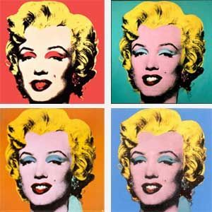 |  |  | - Create a painting in the style of Andy Warhol.  - Explore the potential properties of the visual elements, line, tone, pattern, texture, colour and shape.  - Work in a sustained and independent way from observation, experience and imagination.  - Identify artists who have worked in a similar way.  - Develop ideas using different mixed media using a sketchbook.  - Demonstrate a secure knowledge about primary and secondary, warm and cold, complementary and contrasting colours.  - Create shades and tints using black and white.  - Choose appropriate paint, paper and implements to adapt and extend work.  - Show an awareness of how paintings are created (composition).
Art National Curriculum Skills
Develop Ideas |  |  | Techniques: Painting | Techniques: Drawing |  | Techniques Sculpture
• Develop and imaginatively extend ideas from  starting points throughout the curriculum.  • Collect information, sketches and resources  and present ideas imaginatively in a sketch  book.  • Use the qualities of materials to enhance ideas.  • Spot the potential in unexpected results as work progresses.  • Comment on artworks with a fluent grasp of visual language. |  |  | • Sketch (lightly) before painting to combine  line and colour.  • Create a colour palette based upon colours  observed in the natural or built world.  • Use the qualities of watercolour and acrylic  paints to create visually interesting pieces.  • Combine colours, tones and tints to enhance  the mood of a piece.  • Use brush techniques and the qualities of  paint to create texture.  • Develop a personal style of painting, drawing  upon ideas from other artists. | • Use a variety of techniques to add interesting effects (e.g. reflections, shadows, direction of sunlight).  • Use a choice of techniques to depict movement, perspective, shadows and reflection.  • Choose a style of drawing suitable for the work (e.g. realistic or impressionistic).  • Use lines to represent movement. |  | • Show life-like qualities and real-life  proportions or, if more abstract, provoke  different interpretations.  • Use tools to carve and add shapes, texture  and pattern.  • Combine visual and tactile qualities.  • Use frameworks (such as wire or moulds) to  provide stability and form.
Techniques: Collage |  |  | Inspiring Artists | Techniques: Printing |  | Digital Media | Textiles
• Mix textures (rough and smooth, plain and  patterned).  • Combine visual and tactile qualities.  • Use ceramic mosaic materials and techniques. |  |  | • Give details (including own sketches) about  the style of some notable artists, artisans  and designers.  • Show how the work of those studied was  influential in both society and to other  artists.  • Create original pieces that show a range of  influences and styles. | • Build up layers of colours.  • Create an accurate pattern, showing fine detail.  • Use a range of visual elements to reflect the purpose of the work. |  | • Enhance digital media by editing (including sound, video, animation, still images and installations). | • Show precision in techniques.  • Choose from a range of stitching techniques.  • Combine previously learned techniques to create pieces.

