Geography Curriculum Milestone 2
Aspect of Geography |  | Key Vocabulary |  |  | Sticky Facts |  |  |  | Essential Knowledge
Gods and Mortals  European Country (climate)  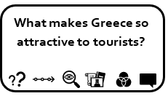 |  | European Union  Mediterranean  Euros  Greek Islands  Coast line  Athens  Climate  Tourism  Land use  Population  Landmarks  Mountains |  |  | - There are 50 countries in Europe.  - Greece has the longest coastline in Europe  - Greece is a mountainous country.  - Greece has a number of islands around its main land which is famous for being holiday destinations.  - The capital of Greece is Athens.  - The climate of Greece is temperate: mild, wet winters; hot, dry summers. |  |  |  | - Know the names of a number of European capitals  - Know the names of, and locate, at least eight European countries  - Use maps to locate 8 European countries and capitals.  - Know at least five differences between living in the UK and Greece.  Field work: Weather recording devices. Compare weather in Farndon that day to weather in a Greek Island.
Romans, Roads and Rivers  Volcanoes and Earthquakes  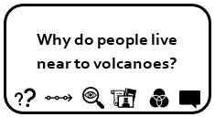 |  | Eruption  Magma  Lava  Dormant  Vesuvius  Aftershock  Fault line  Tectonic plates  Landslide  Tsunami  Hurricane |  |  | - Volcanoes are caused when magma rises to the surface of the Earth, which causes bubbles of gas to appear in it. This gas can cause pressure to build up in the mountain, and it eventually explodes.  - Earthquakes are usually caused when rock underground suddenly breaks along a fault. This sudden release of energy causes the seismic waves that make the ground shake.  - Europe's three active volcanoes, Etna, Stromboli, and Vesuvius are all located in Italy. |  |  |  | - Know what causes a volcanic eruption.  - Label the different parts of a volcano
Dungeons and Dragons  UK Place knowledge  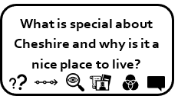 |  | Towns  Villages  Counties  Cities  Road  Motorway  Settlement  Village  Farm  House  Woodland  Vegetation  Sandstone rock  Vale of Cheshire |  |  | - Castles were built on large hills near water so they were easier to defend. Built all over the UK  - Beeston was a Bronze Age settlement and an important defended settlement and metal working centre.  - Beeston is a village of up to 200 people.  - 6 largest cities in England are London, Manchester, Birmingham, Leeds, Liverpool and Sheffield.  - Cheshire borders onto Lancashire, Shropshire, Derbyshire, Staffordshire and West Riding (Yorkshire)  - Holt Castle was built on the Welsh – English border in the 13th Century on the banks of the River Dee. |  |  |  | - Know the names of, and locate, at least eight counties and at least six cities in England  - Look at Beeston as a settlement. Comment on topographical features and the Physical and Human geography of the area.  - Compass Points on maps  - Field work: Visit to Beeston castle. Look at land use from aerial pictures, human and physical geography. Also, include compass points.
From Ambleside to the Alps  Compare UK North West to northern Italy.  Explorers on mountain ranges  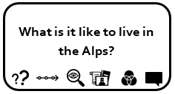  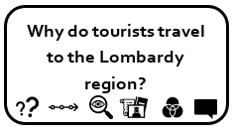 |  | European Union  Mediterranean  Rome  Euros  Alps  continent  country  capital  region  settlement  rural  urban  terrain  population  climate |  |  | - Italy is a boot-shaped peninsula that juts out of southern Europe into the Adriatic Sea and Mediterranean Sea.  - The capital of Italy is Rome.  - Climate: predominantly Mediterranean; Alpine in far north; hot, dry in south  - The Alps dominate central Europe and are within at least 7 different countries.  - The largest peak is Mount Blanc  - In the North West of England there are 5 counties: Greater Manchester, Merseyside, Cheshire, Lancashire and Cumbria.  - In Cumbria, there is the Lake District and Skafell Pike and in the Lombardy region there is Lake Como and Lake Garda. |  |  |  | - Know the names of some countries in Europe and locate on a map.  - Know England is in the UK and within Europe.  - Know the different counties within the Northwest of England.  - Know at least five differences between living in the UK and Italy.  - Know how the climate of Italy and the UK compare.  - Know what aspect of each area attracts tourism.  - To know how the size and scale of England compares to Italy.  Field work: Client holiday cards. Choose where they might go on holiday in northern Wales and Italy.
 |  | Peak  Valley  Ridge  Cliff  Plateau  Hill  Terrain  Range  Tectonic plates  Foldmountains |  |  | - Mountains make up one-fifth of the world’s landscape.  - Mount Everest is the world highest mountain and it is 8, 850m high.  - Generally mountains are higher than 600m if they are less they are called hills.  - British mountains: Ben Nevis; Snowdon; Pennines; and Skafell Pike.  - Fold mountains are formed when two plates collide, causing the Earth’s crust to crumple and fold. |  |  |  | - Know how mountain ranges are formed.  - Know where the main mountain regions are within the UK.  - Identify mountain ranges across the different continents.  - Know the names of a number of the world’s highest mountains
Streetwise  Skills and Field Work |  | Symbols  Keys  Atlas  Digital Mapping  North  South  East  West  Compass  Tithe maps |  |  | - Tithe maps show how land has changed over time. Compare the physical geography of the past.  - Farndon is a village in Cheshire on the banks of the River Dee  - Holt bridge (medieval and apparently haunted) separates Farndon from the Welsh Village of Holt and its Welsh name is Rhedynfre (been important crossing in battles – Anglo Saxon / Civil War)  - The village was renowned for its strawberry fields until WWII.  - The Farndon cliffs are a Site of Specific Scientific Interest.  - St Chads church dates back to King Edward III. |  |  |  | - Local History of Farndon and how human geography changed over time.  - History of the strawberry fields (link with school badge)  - Where live. Where is the school - Planning route  - Use fieldwork to observe, measure, record and present the human and physical geography of Farndon: surveying shops / types of houses / material  - Know how to plan a journey within the UK, using a road map from Farndon to somewhere in the UK.  - Using OS maps for the area (8 figure grid references) and compass points.  Field work: Survey of the village of Farndon. Look at noise and litter pollution.  Field work: Use aerial maps of Farndon to look at a possible improvement to the amenities in the village.  Field work: Change within the village and speak to people to find out who is affected in negative / positive way.
It All Started in a Cave  Skills and Field Work  Location Knowledge |  | Neolithic Settlement  Skara Brae  Aubrey holes |  |  | - Journey of the stones went from Preseli mountains, through south Wales and down into Salisbury.  - Skara Brae is in the Orkney Islands and was a Neolithic village. |  |  |  | - Burwardsley / Beeston ( local history for Bronze Age settlements and stone age or Iron age workshops.  - Look at Stone Age settlements of Stoneage and Skarae Brae. Locate on maps bronze/ iron age settlements in Cheshire.  - Map journey of the stone for Stonehenge.
Geography Substantive Concepts
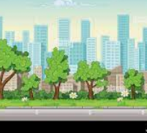 | 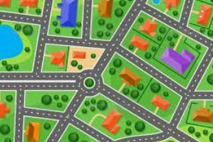 |  |  |  | 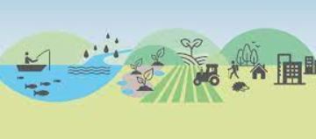 |  |  | 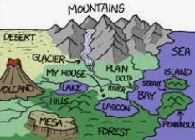 |  | 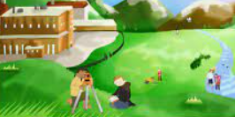 |  | 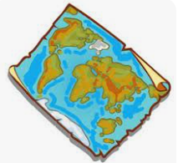
Place:  What is the place like? | Space:  How are the spaces organised |  | Size:  Personal, Local, Regional or Global |  | Environment: How we use the natural world | Connections: Study of people, cultures, places and processes |  | Processes: Physical and Human Geography |  | Field Work: Thinking about what places are like and why. |  | Map Skills:  Study of maps and map making
Geography Disciplinary Knowledge
Geographical Significance |  |  |  | Geographical Responsibility |  |  | Geographical Communication |  |  |  | Geographical Enquiry
- Name and locate the countries of Europe and identify their main physical and human characteristics.  - Name and locate counties and cities of the United Kingdom, geographical regions and their identifying human and physical characteristics, including hills, mountains, cities, rivers, key topographical features and landuse patterns |  |  |  | - Identify how we affect where we live in a positive and negative way, explaining own views about locations, giving reasons.  - Identify how a change of land use (such as a new cinema complex) could positively and negatively affect an area.  - Describe the effects of tourism on a geographical region in a positive and negative way. |  |  | - Describe key aspects of physical geography, including rivers; mountains; volcanoes and earthquakes and the water cycle.  - Describe key human geography, including settlements and land use.  - Use maps, atlases, globes and digital/computer mapping to locate countries and describe features.  - Use fieldwork to observe and record the human and physical features in the local area using a range of methods including sketch maps, plans and graphs and digital technologies.  - Use a range of resources to identify the key physical and human features of a location.  - Use the eight points of a compass, four-figure grid references, symbols and key to communicate knowledge of UK and Europe. |  |  |  | - Ask and answer geographical questions about the physical and human characteristics of a location.  - Understand how physical characteristics and land use patterns of areas studied have changed over time.  - Describe how the locality / village of the school has changed over time.  - Describe geographical similarities and differences between countries such as northern regions of Wales and Italy.  - Describe cause and effect of humans and nature on landscapes and settlements, including tourism in Italy / Greece and natural disasters such as volcanic eruptions and tectonic plate movement.

