History Curriculum Milestone 3 Substantive Knowledge
Period of History |  | Key Vocabulary |  |  | Sticky Facts |  |  |  | Essential Knowledge
Traders and Raiders  Viking and Anglo Saxon struggle  866AD to 1066AD  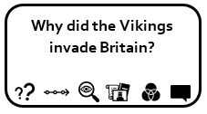  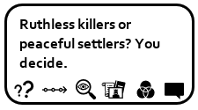 |  | Danelaw  Conquered  Invaders  Territory  Rival Kings  Viking Raids  Longhouse  Beserkers  Jorvik  Odin  Longboat |  |  | - 866 Vikings invade  - 924 Edward the Elder was killed in Farndon.  - Not all Vikings were warriors. Some came in peace and were farmers.  - Alfred the Great was the King of Wessex; he defeated the Vikings at the Battle of Edington in 878AD.  - No Vikings had horns on their helmet.  - The land occupied by Vikings was called Danelaw.  - They spoke norse and their alphabet was made up of runes.  - The names of the week originate from Viking.  - A Longboat was a narrow boat that was used to raid coasts .  - Vikings lived in Longhouses which were long hall like buildings where several families would live. |  |  |  | - Know where the Vikings originated from and show this on a map  - Know that the Vikings and Anglo-Saxons were often in conflict  - Know why the Vikings frequently won battles with the Anglo-Saxons  - Edward the Elder extended his authority over Danish held territories.
Endangered  Then Ancient Mayans  1800BC to 250AD  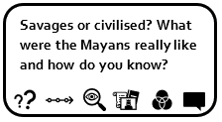  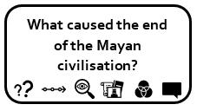 |  | Rituals  Culture  Astronomy  Ruler and Noble classes  Chechen Itza  Step Pyramid (temple)  Glyph  Codices  Ahau (King)  Huipil (Clothing) |  |  | - 2600BC Mayans lived in area called Yucatan in central America  - The Mayan, or Maya, peoples made their home in an area known as Mesoamerica (modern day Mexico and Central America).  - Mayan writing consisted of hieroglyphs  - Mayans were expert mathematicians and astronomers which they used to make calendars.  - Mayan religion involved human sacrifice and bloodletting. They believed those that died went to the “place in the misty sky”.  - Mayan society was formed of a number of city states who each had a ruler. |  |  |  | - Know where the Mayans originated and can show it on a map of central America.  - Mayan civilisation known for its maths, astronomy, calendars and architecture  - Describe the daily life of the Mayan people: food, clothing, housing, buildings and entertainment.  - Explain the hierarchy of Mayan society, knowing at the top was the King and Royal family. An educated elite of scribes, priests and nobles formed the ruling class.  - Understand Mayan religion and why it was important to them.
Walk Like An Egyptian  The Ancient Egyptians  6000 BC to 332BC  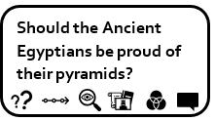 |  | Civilisation  Pharaohs  Tombs  Pyramid  Chamber  Scarab / Amulet  Vizier  Sarcophagus  Mummification  Canopic Jars  Hieroglyphics  Papyrus |  |  | - There are over 2000 Egyptian Gods; most were in human form and some had the heads of animals.  - Egypt split into 2 parts: Red Land and Black Land: this was the fertile soil near the Nile.  - Cleopatra was the last Pharaoh of Egypt before Roman rule.  - Pharaohs were buried with their treasure in the Valley of the Kings.  - First civilisation to invent writing: Hieroglyphics are an ancient Egyptian way of writing using pictures rather than letters.  - Tutankhamun ruled during the New Kingdom. Known as boy king and famous due to discovery in 1922. |  |  |  | - Know about the impact that the Ancient Egyptians had on the world.  - Know where the Egyptians originated and can show it on a map.  - Describe the daily life of the Ancient Egyptian people: food, clothing, housing, buildings and entertainment.  - Understand ancient Egyptian religion and why they constructed great pyramids.  - Explain how important the Nile was to the Ancient Egyptians.  - Know how to place features of historical events and people from the past societies and periods in a chronological framework
Let Me Entertain You  A change in aspect of social history: Entertainment  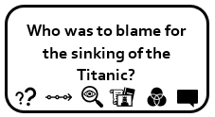  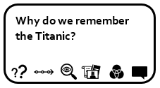 |  | Migration  Empire  Nomads  Immigrant  Over population  The Americas  Immigration  Quotas  Refugee  Asylum Seeker  Displacement  Ocean Liner  Maritime disaster |  |  | - A long journey to a new home is called a migration.  - Peoples who move and have no permanent home are called nomads.  - An immigrant is someone who moves from one country to another.  - People may migrate due to promise of better jobs / life; land; safety; forced to leave; slavery.  - The Great Atlantic Migration was after 1800, where Europeans migrated to the US due to over population, war or natural disaster.  - The Titanic was travelling to America and struck an iceberg and sunk  - The titanic was the biggest ship in the world.  - Most of those emigrating were 3rd class, looking for a better life.  - It did not have enough lifeboats: Only 20 when it needed 64. |  |  |  | - Know about a theme in British history which extends beyond 1066 – the migration of people to and from Britain important in relation to British history.  - Explain why people choose to migrate.  - Identify how Britain has had a major influence on the world.  - Know why migrants have come to Britain and what were their experiences like.  - Learn hat impact has migration had on our country and others within the British Empire.
Child Of Our Time  The changing experiences of the lives of children in Farndon beyond 1066  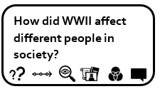  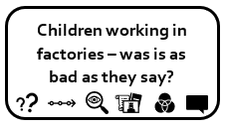  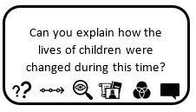 |  | Dame schools  Industrial revolution  Governess  Dunce cap  Drill  The 3 R’s  Blind Man’s Buff  Hopscotch  Writing Slate  Abacus |  |  | - 1844 Factory Act stopped children working more than 6.5 hours a day; in early Victorian period children expected to work.  - 1870 schools provided for 5 – 13 year olds; it was law.  - Children had to pay to go to school and were turned away.  - Poor children went to Dame schools; rich children were taught by a Governess and at 10 would got to a Public school.  - Children were taught the 3 Rs; and lessons such as geography, history, music and drill (their version of PE).  - Classes were big; teachers were very strict and punishments included the cane and dunce cap. |  |  |  | - Describe the daily life for Victorian children: clothing, housing and school.  - Explain the differences between the lives of rich and poor Victorian children in the village.  - Know the impact the industrial revolution had on children and their roles in Farndon.
 |  | Evacuation  Nazi  Axis  Allies  Blitz  Blackout  Propaganda  Home Front |  |  | - 1939 Britain declares war on Germany  - The war took place between the Allies and the Axis Powers.  - Adolf Hitler and the Nazi Party wanted Germany to rule Europe. They invaded Poland which triggered the war.  - After D Day landings, Allies push into Germany leading them to surrender.  - Evacuation was the organised movement of children and the vulnerable from towns and cities to safe zones because of bombing. .  - The Blitz was a series of bombing raids in the war.  - 8th May 1945 Germany surrender |  |  |  | - Know the impact the war had on local children with a focus on evacuation, rationing, propaganda and changing role of women (shed on school grounds was land girls. Farndon took in evacuees from Liverpool) https://www.bbc.co.uk/history/ww2peopleswar/stories/52/a3131452.shtml
History National Curriculum Substantive Themes
Legacy | Exploration |  |  | Invasion and Settlement |  | Technological Development |  | Monarchy |  | Societal / Cultural Change |  | Empire
The Ancient Mayans |  |  |  | The Ancient Mayans  Struggle between Saxons and Vikings |  | Ancient Egypt  Leisure and Entertainment  Child in Our Time |  | Struggle between Saxons and Vikings |  | Struggle between Saxons and Vikings |  | The Ancient Mayans
History National Curriculum Disciplinary Knowledge
Historical Interpretations through sources and evidence. |  |  | Historical Knowledge of chronology, change and continuity |  |  |  | Historical overview of world history and historical significance |  |  |  | Historical Enquiry, looking at cause, consequence, similarities and differences of periods studied.
• Use sources of evidence to deduce information about the past.  • Select suitable sources of evidence, giving reasons for choices.  • Use sources of information to form testable hypotheses about the past.  • Seek out and analyse a wide range of evidence in order to justify claims about the past.  • Understand that no single source of evidence gives the full answer to questions about the past.  • Know that different interpretations exist and can change in accordance with evidence and different means of analysis. |  |  | • Describe the main changes in a period of history (using terms such as: social, religious, political, technological and cultural).  • Identify periods of rapid change in history and contrast them with times of relatively little change.  • Understand the concepts of continuity and change over time, representing them, along with evidence, on a time line. |  |  |  | • Give a broad overview of life in Britain from medieval until the Tudor and Stuarts times.  • Establish clear narratives within and across periods studied.  • Compare some of the times studied with those of the other areas of interest around the world.  • Describe the social, ethnic, cultural or religious diversity of past society.  • Identify that some historical events have had their status ascribed to them. |  |  |  | • Use appropriate historical vocabulary to communicate.  • Regularly address and sometimes devise historically valid questions  • Select and combine info about potential causes and structure into an explanation or argument.  • Develop an understanding of similarities and differences of periods studied on different scales.

