Farndon Primary School  Student Newspaper | ^{The}FPS  newspaper
Summer 2021 | Editor and Chiefs:  Bethanie, Charles, Erin, Lacey,  Sienna and Tilly |  | Issue: 19
Animals!
By Tilly
Let's talk about monkeys...different monkey species eat a variety of food such as fruit, insects, flowers, leaves and reptiles. Most monkeys have tails. Groups of monkeys are known as a “tribe”, “troop” or “mission”. The Pygmy Marmoset is the smallest type of monkey, with adults weighing between 120 and 140 grams.

Did you know that giraffes are the tallest mammals on Earth? They can run as fast as 35miles an hour over short distances, or cruise at 10mph over long distances. A Giraffe's neck is too short to reach the ground. Giraffes only need to drink once every few days! Giraffe’s legs are taller than many humans-about 6 feet.

A typical animal eats half the day—a full 12 out of every 24 hours—and relieves itself dozens of times a day. It takes 28 pounds of bamboo to satisfy a giant panda's daily dietary needs, and it hungrily plucks the stalks with elongated wrist bones that function rather like thumbs. Pandas will sometimes eat birds or rodents as well.
Did you know that seals have a layer of fat under their skin called blubber, which keeps them warm in water? Their slick fur coat is streamlined for gliding through water. A seal's whiskers help it to detect prey in dark, murky waters. Seals live on average for 25-30 years, females usually live longer than males.

Let's talk about penguins, a group of penguins in the water is called a raft but on land they're called a waddle! The black and white “tuxedo” look donned by most penguin species is a clever camouflage called countershading...Penguins may huddle together for many reasons, penguins evolved to fly underwater.

Did you know that elephants are the world's largest land animal, you can tell two species apart by their ears? Their trunks have mad skills, their trunks are actually their teeth, and they’ve got really thick skin and are always constantly eating.
This is all from me,
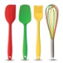
 | ARTICLE 12, 13,  14, 15 & 31 | Saying of the month: Friends, sun, sand and sea that sounds like summer to me.
Puzzles, Conundrums and things to amuse!
16 great riddles for you, your friends and your family to enjoy!!
(: Answers for → summer <--riddles in brackets :)

- What gets wetter the more it dries? (A towel)
- What lives in winter, dies in summer, and grows with its roots upward. (An icicle)
- What travels all the way around the world but always stays in one spot? (A stamp)
- I have no eyes, no ears, and legs, and yet I help move the earth. What am I? (An earthworm)
- A man was walking in the middle of nowhere and it started to rain. He had no umbrella and no hat, but not a single hair on his head got wet. How can this be? (The man was bald!)
- What question can never have an (honest!) answer to? (Are you asleep)
- Why do bananas use sunscreen? (Because they peel)
- What is full of lots of holes, but can still hold water? (A sponge)
- What do you call a dog on the beach in summer? (A hot dog)
- I am made of cloth. I am used by campers. A person can sleep in me. I am not a tent. What am I? (A sleeping bag)
- I bring music wherever I go. I keep things very cold. I have wheels. People give my (An ice cream van)
- I am a frozen treat. I am not in a cone. I do not have a stick. Part of my name sounds like a day of the week. What am I? (An ice cream sundae)
- What does the sun drink out of? (Sunglasses)
- What would you call a snowman in summer? (A puddle)
- What’s black and white and red all over? (A sunburnt zebra)
Can you guess them all?

Puzzles, Conundrums and things to amuse!
Fill in the gaps to make a story.
Once upon a time a ___________ danced on a _____________ and a ____________ joined in. And then the ___________ learned to _______________ and the ____________ got jealous. Then a ___________ saw him/her. They all __________ together.

Can you Work out the words using the pictures to help you?

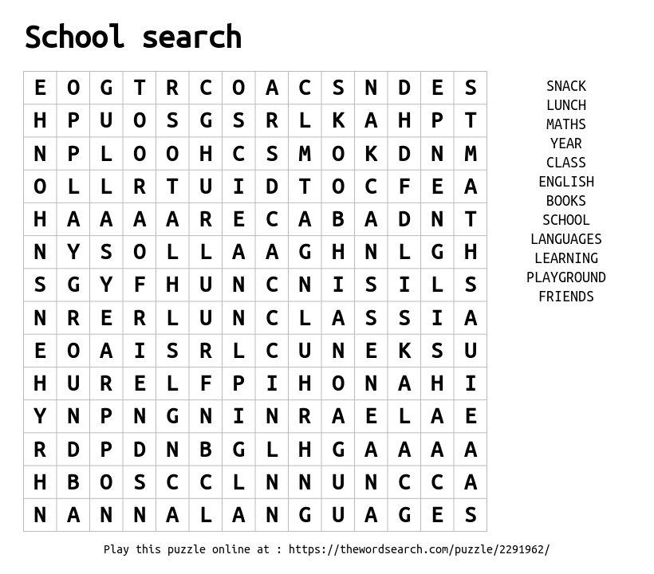

Junior Safety Officers
May
Our first focus was Walk to School Week and we asked everyone to try to walk to school. If you live quite far away why not ask whoever drives you to park 5 minutes away from school and then walk from there. Walking to school reduces traffic and the amount of pollution in the air which means much cleaner air for children to breathe in on the way to and from school. Walking will help get you ready to learn and wakes you up in the morning. Walking home will help you to relax. Walking to school means there will be less traffic; less traffic means less pollution and less pollution It also reduces the amount of cars parking near school. This makes it easier for everyone to get to school safely.

Our second topic this month is Helping to Keep Others Safe. Did you know that every child and teenager under the age of 18 is protected by the UN Convention on the Rights of the Child? No matter whom they are where they come from or what they believe in. the convention protects every child’s right to be; treated fairly, protected, heard, be healthy and be educated. You can help others to keep safe by acknowledging these rights and acting on them if you are worried about yourself or someone else. You should tell a trusted adult like a teacher or phone Child line for help and advice. If it’s an emergency phone 999 if something bad is happing at the time. Or phone 111 if it is something that has happened and you or your family want to report it.

June
The first focus for this month is… Cycling, Scooting and Roller. Cycling is great because it gets you active and is a healthy way to get around. It’s also environmentally friendly meaning there will be less pollution in the air. Here are some tips for cycling out and about.
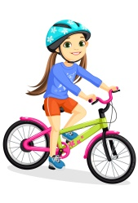
- Ride in a position where you can see and be seen.
- Give way to others and be prepared to stop or slow down.
- Wherever possible use cycle routes or paths away from traffic.
- Always look all around before you set off and give clear hand signals and look out for obstacles in the road.
- Ring the bell as a warning to others to let them know you are approaching.
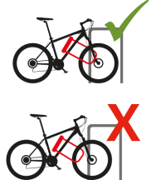
- Concentrate – NEVER use a mobile phone or listen to music.
- Get trained.
Our second focus is linked to our first and is Cycle/ Scooter Safety and Security. We have some tips to help you keep you and your bike or scooter safe.
- First get a bicycle lock – make sure you secure your bike tightly with a good security lock so that it is hard to move when it’s parked.
- Try to make sure you attach your bike to a solid permanent object like a lamp post or a bike stand.
- Remember to keep a note of your bikes identification number, ask your parent or carer to help you find it on your bike.
- You can get your bike chipped or get a tracker, ask your local police how to keep your bike safe.
- Always complete a five-point bike check, checking Tyres, Brakes, Chain, Lights and Reflectors before setting off, don’t forget to wear a helmet and wear something brightly coloured or fluorescent in the day and at night something white of reflective.

Junior Safety Officers
July
The first focus for this month is Summer Holidays. It’s the sumer holidays and there are a few tips we’d like to share with you to help keep you safe over summer

The second focus for this month is Year 6 Transition. So your transition into Year 7 is approaching, have you got all the information you need.
Craft
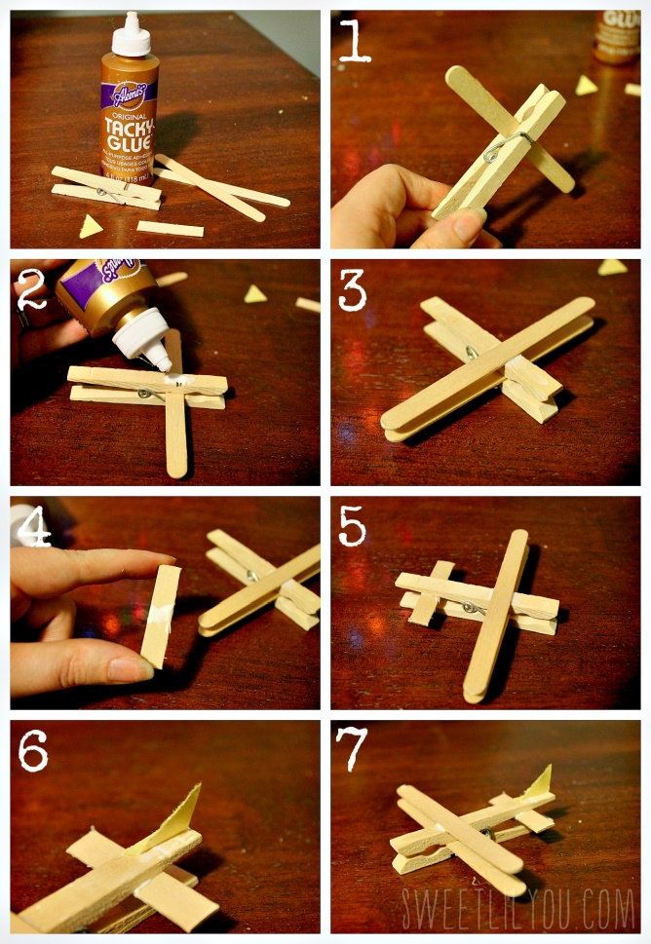
Follow the pictures to make these amazing origami butterflies. 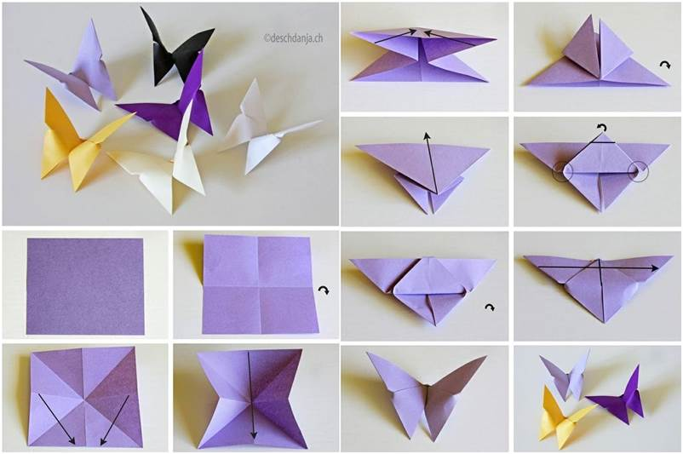

Lollypop and Peg Aeroplane

You will need: Glue, two lolly/craft sticks, one wooden peg, and a small piece of card.

Step 1: Open up the clothes peg and insert one craft stick (you can use a little dab of glue to secure it.)
Step 2: Dab glue on the clothes peg above where the first “wing” is.
Step 3: Attach the second craft stick to the top of the clothes peg (This creates the bi-plane wings!)
Step 4: Dab glue on a smaller craft stick (Or you can cut a piece off of a larger one–like we did here)
Step 5: Attach this small piece to the back of the clothes peg. (This creates the tail wing)
Step 6: Attach a small triangle of construction paper to the tail (This is the rudder!)
Step 7: Let dry, and then you can paint your airplane.
Recipe
How to Make a Lemonade Stand
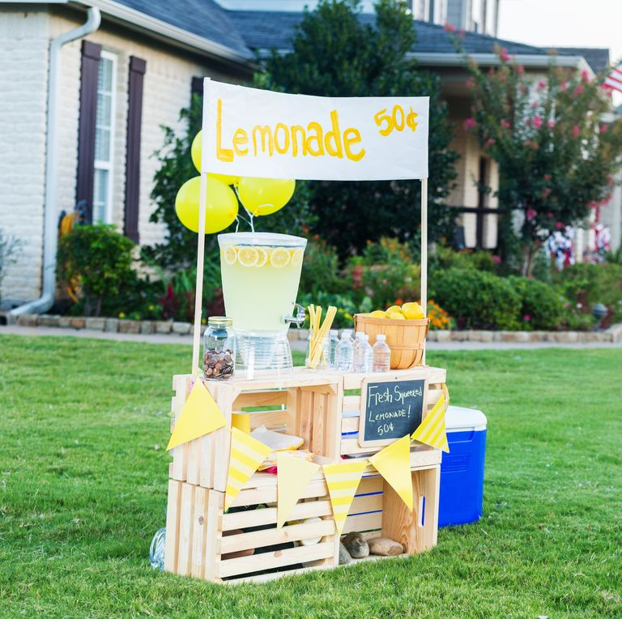
What you need:
- Sugar
- Water
- Lemons
- Cups and a jug
- Syrup
- Sieve
- Table from house

How to make the lemonade:

- Add sugar and 2 cups of water to a saucepan.
- Juice your lemons. Strain the lemon juice through a fine mesh sieve into a pitcher.
- Combine syrup and lemon juice. Add more water, to taste, until you reach your desired lemonade sweetness.
- Put in the fridge to cool.
- You can get a table from your house to put your jug of lemonade on. Set out as many cups as you need and add straws if you wish.
- Make sure to have a reasonable price for your drinks and a tip jar for money. Decorate your stand however you want and enjoy!

Recipe
Summer smoothies
Treat yourself with these delicious smoothies

Banana and Strawberry Smoothie
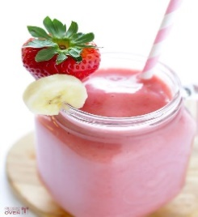
You will need the following…
- Frozen strawberries
- Fresh ripe banana slices
- Any type of milk cow milk, Almond milk etc.
- Add ice (optional)
- Blender

Here is how to make it
Step 1. Combine all the ingredients and add them to the blender
Step 2. Blend all the ingredients until smooth (if it is too thick add in a bit of extra milk or water. If too thin add more strawberries or banana
Step 3. Now all you have to is serve
Mango, Pineapple and Coconut Milk Smoothie
You will need the following items...
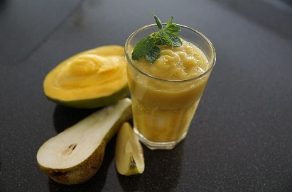
- 1/13 of coconut milk
- 2/12 cup of frozen pineapple
- 1 cup of frozen mango
- Lime zest to taste
- 1 cup of ice

Here is how to make it
- Add all the ingredients into the blender.
- Add a few gratings of lime.
- Blend on a high speed until smooth, serve immediately and enjoy!!
And enjoy!!!

Recipe
Red velvet cookies recipe
(You might want an adult to help you with this one!)
Ingredients
- 175 grams of soft salted butter
- 200 grams of light brown soft sugar
- 100 grams of caster sugar
- 1 large egg
- 2 tsp of vanilla extract
- ½-1 tbsps. of red food colouring gel depending on strength
- 225 grams of plain flour
- 25 grams of cocoa powder
- ½ tsp of bicarbonate of soda
- 150 grams of white chocolate chips or chunks
For the drizzle
- 2 tbsps. of soft cheese
- 6 tbsps. of icing sugar

Method

  - Beat the butter and sugars together with an electric whisk until pale and fluffy. Beat in the egg, vanilla and food colouring until you have a bright red batter. Sieve over the flour, cocoa and bicarb. Fold everything together to make a stiff evenly-coloured dough, then fold in the chocolate chips.
  - Put the dough on a sheet of baking parchment, fold the parchment over the dough and mould into a sausage shape about 6cm wide. Chill until ready to bake. Will keep for a week in the fridge or one month in the freezer.
  - Heat the oven to 190C/170C fan/gas 5. Cut the cookie dough into 1cm thick slices using a sharp knife and arrange on two large baking sheets lined with baking parchment well-spaced apart so they have room to spread in the oven. Bake in batches, keeping the unbaked cookies on the sheet in the fridge while the rest are baking.
  - Bake in the middle of the oven for 13-15 mins until the cookies are crisp at the edges, but still soft in the centre. Leave to cool on the baking sheet for a few minutes, and then transfer to a wire rack to cool completely. Beat the soft cheese in a small bowl to a loose consistency, and then stir in the icing sugar. Use a piping bag or spoon to drizzle the icing over the cookies. Un-iced cookies keep for five days in an airtight container, or two days iced.

Dance Part 1
Summer Challenge
Can you learn our dance?
Follow the steps and then put it all together.

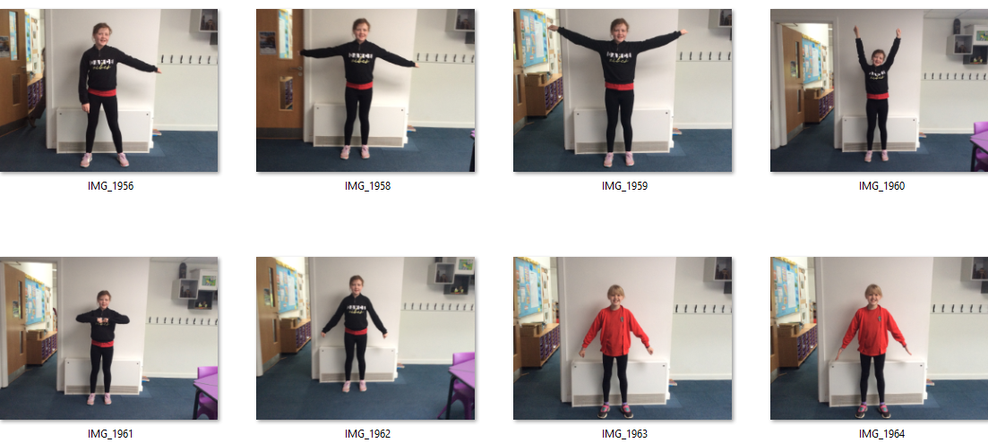

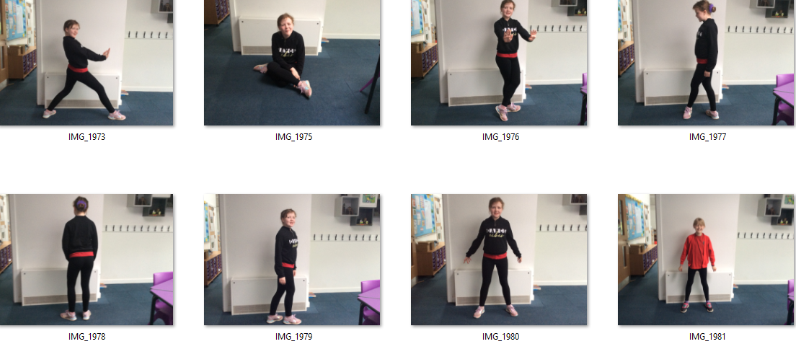
Dance Part 2

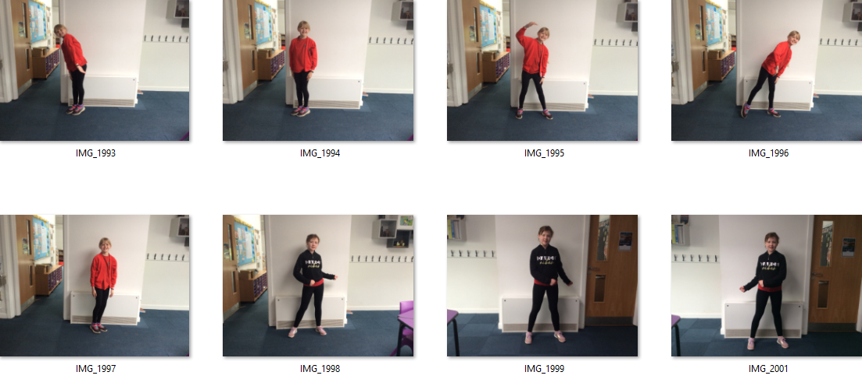
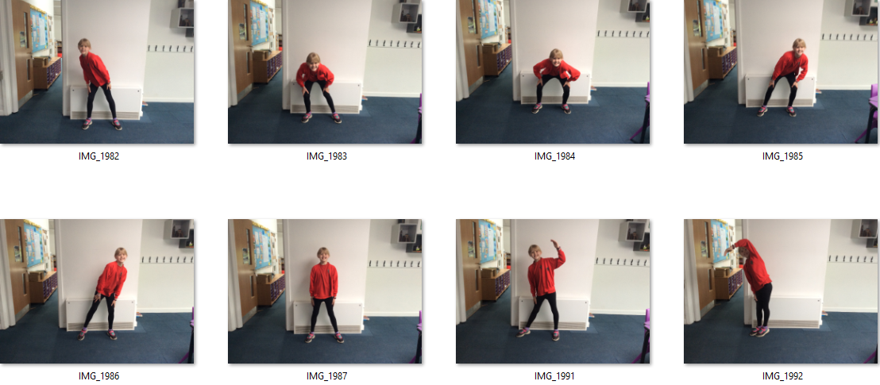
Dance Part 3
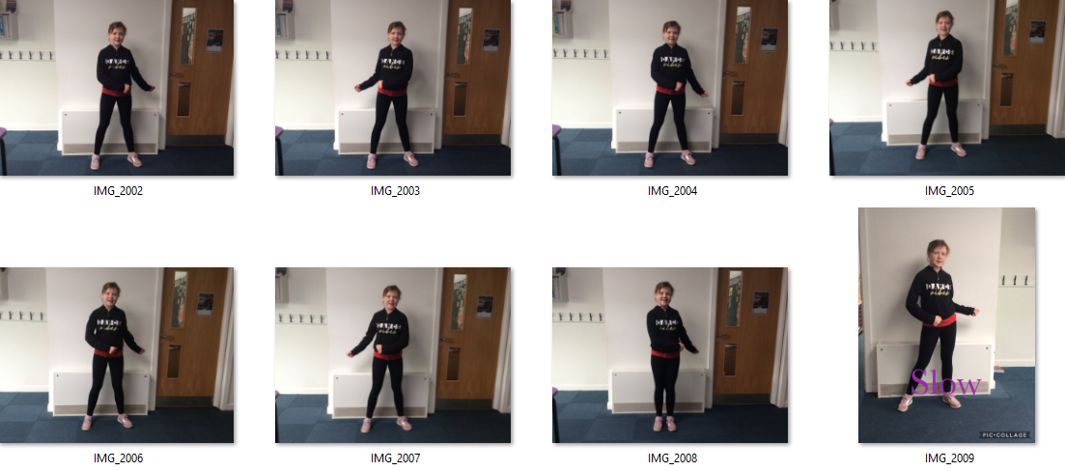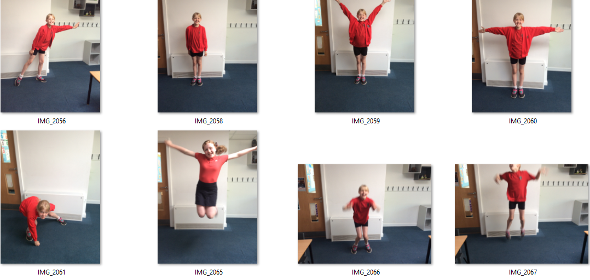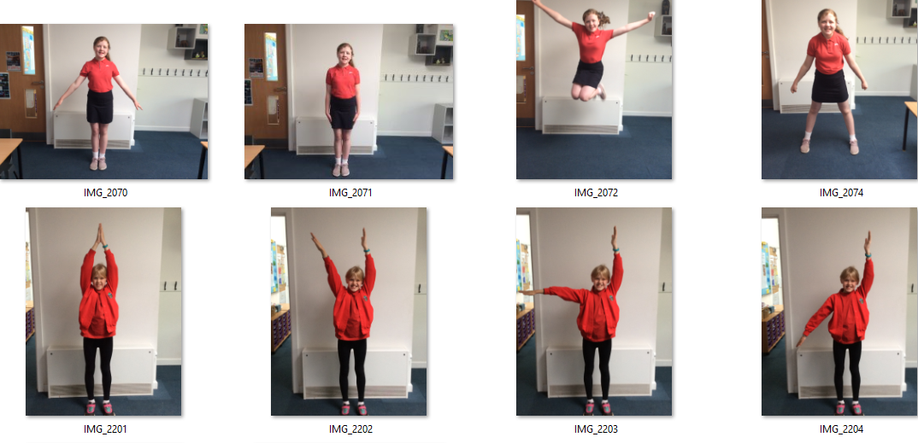

Dance Part 4
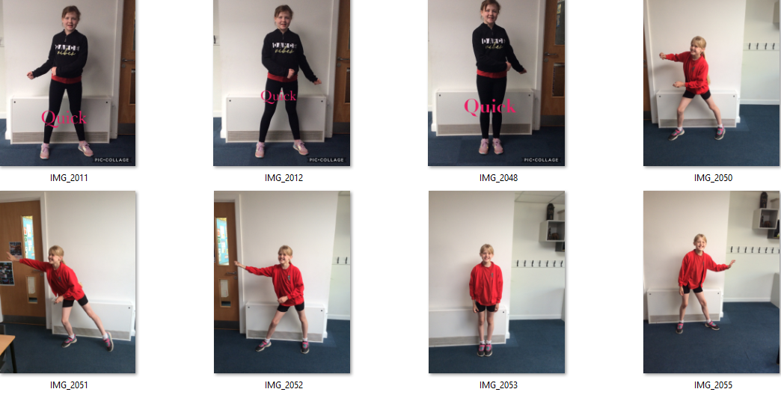

Did you manadge to complete it?
We hope you enjoyed it and had lots of fun.

Infant Fun
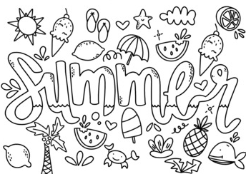
Colour me in

Junior Fun
Colour me in

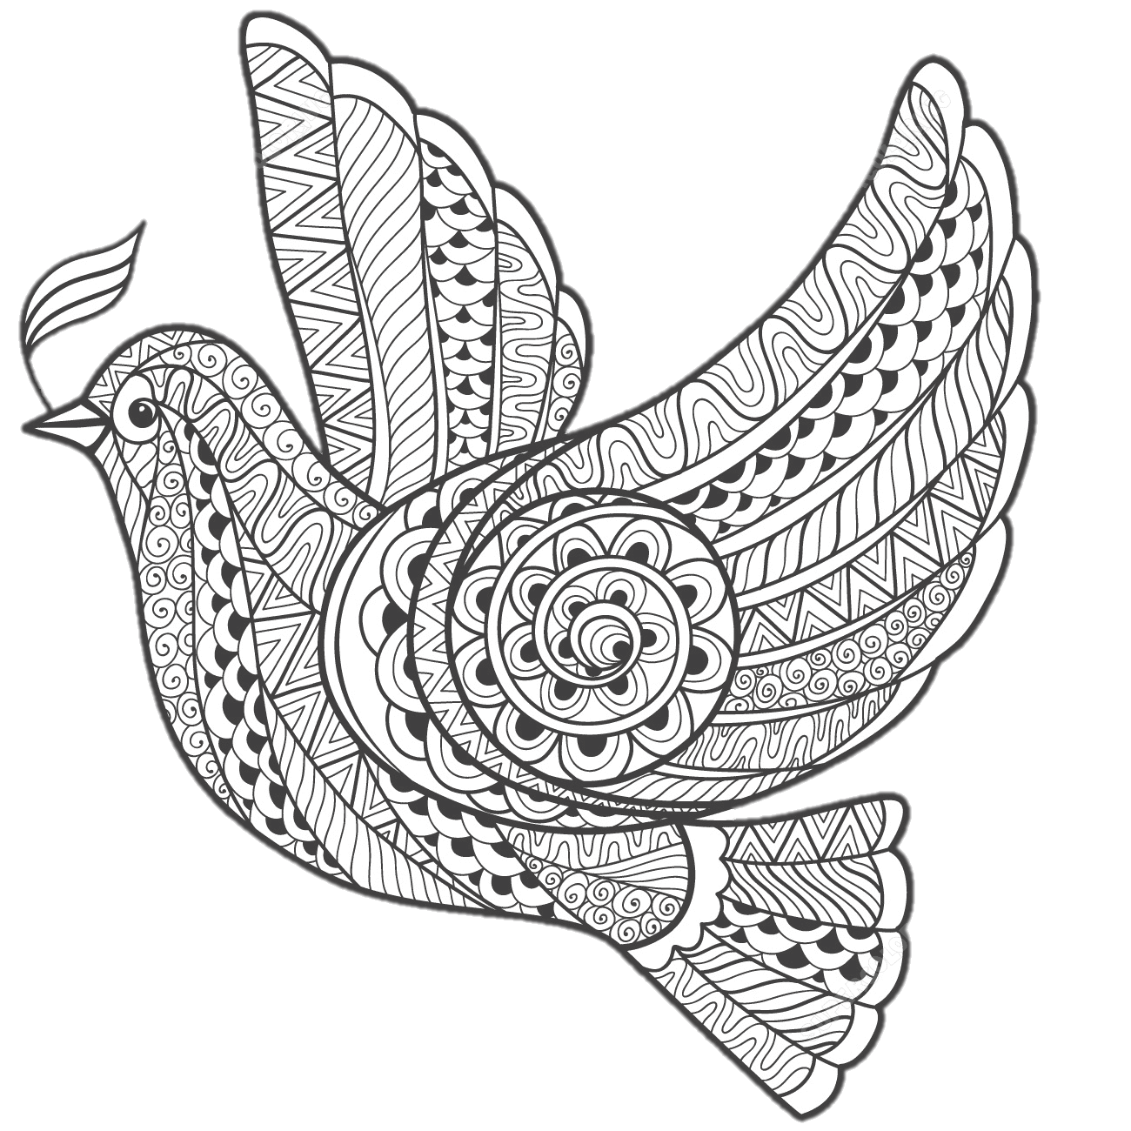

Acheivements
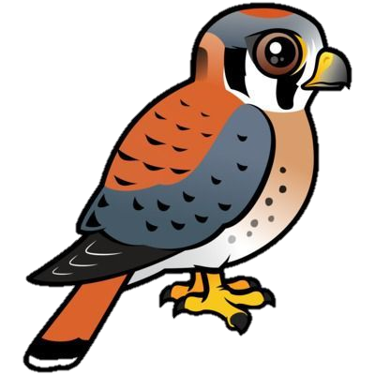Kestrels
Ben – Rugby Players Player Trophy
Alfie – Got into Tennis Welsh County
Zach – Members badge – Golf
Hannah – Passed her ballet exam.
Josh – 7th out of 239 (adults and juniors) in 5km run around Erdigg
Olly – Rugby – Man of the Match
Sophia – Chosen to do a trail for Manchester Thunders netball team in September
Noah and Kayla – Passed their Grade 4 piano
Mini – Came 1st in 800m athletics for her year group.
Ailish – Passed her Bronze Award 3 at Pony Club
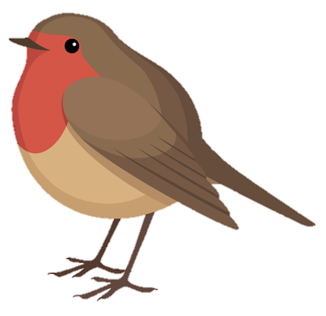 Robins
Elisabeth - Donated her cut hair to the Princess Trust
Patrick – Passed his under 8’s and was awarded a shield at rugby.
Katie – Has started doing jumps on her horse.

