 Unlocking the potential…

Farndon Primary School
DFE Number 896 2273



School Travel Plan Document



INTRODUCING OUR SCHOOL

Name: Farndon Primary School

Address: Churton Road, Farndon, Chester, CH3 6QP

Telephone Number: 01244 981280 Email: head@farndon.cheshire.sch.uk
Head Teacher: Mr Andrew Walker

Number of staff: 32 (incl. all posts) Number of pupils on roll: 202

Number of SEN pupils: 8 Number of SEN Pupils with top-up funding: 4

Context

Farndon Primary School is a one form entry rural village school; situated 8.9miles from the city of Chester and 6.5 miles from Wrexham. It sits on the border of Wales, adjacent to the village of Holt, meaning a significant proportion of the school’s intake is from Wales. There is a bus route from Wrexham to Chester that operates Monday to Saturday.

The school is currently a 7 class school with an additional Nursery. Our PAN is 30 meaning we can take up to 210. We are currently at 206 pupils. In Nursery (14)
We have a Reception class (26), Y1 class (30), Y2 class (30) Y3 class (30) Y4 class (32) Y5 class (31) and Y6 (27) class.

Historically, children have come to the school from a wide area as the village of Farndon itself cannot sustain the current school numbers.
The demographics of the school numbers are outlined later but the current success of the school means that the major number of children at the school will continue to come from outlying areas.

As part of the Basic Need programme and the allocation of S106 monies, Farndon Primary School has been awarded approximately £1.2 million for the purpose of creating additional pupil places and constructing additional accommodation on the school site.
New housing developments totalling approx.230 houses are currently built or planned within close proximity of the school and this suggests an increase in pupil numbers.

Building work is expected to begin Summer 2017. Partial completion is expected at the end of September 2017 with the rest of the building work to be carried out the following year. The school is expected to grow to its new PAN intake of 45 over the next 7 years reaching its full capacity within the academic year 2025/2026.

Currently, some staff members walk as they live locally, so staff/car numbers are currently less than could be expected, however our staff number would increase from 33 to approx. 42 to incorporate all provision offered.

This travel plan represents the current situation at Farndon Primary School but also attempts to give some indicators of future demand (as per the expected new PAN), based on the historical demographic evidence available.

Future developments

      - From 2017/18 the school will have an intake number of 45 with nursery provision of up to 26 children due to potential changes to funding, offering up to 30 hours. Over the next 4 years, the school will grow to 11 classes with mixed classes and 315 pupils in total.

- Staff number would increase from 32 to approx. 42 to incorporate all provision offered.

- New housing developments in the area will continue to affect the school place pressure on school. New intakes of children growing the number of children on roll.

- Staff levels – impact on car use by increased number of staff required

- Redesign of front of school to meet needs of access and parking

- Car use to grow according to increased number of children in school. Monitor the effect on the community and the school in terms of road infrastructure.

- Promote use of car share.

- Investigate use of walking bus as appropriate to village accessibility.

- Liaise with Parish Council over possible crossing point or patrol which is staffed.

- Liaise with property developers over a path and entrance into the school from the estate.

Current Staff details at our school

Number of teachers (T) 13
Number of teaching support staff (TA) 9
Number of non-teaching staff 12

Total number of employees at school 34

Total number of staff car parking space 20
Total number of parking spaces for disabled 1
Total number of cycle racks/spaces for staff 2
Total number of spaces available 21

No | Name | Post | Hrs | F/t or P/t or  Job share | Travel mode
1 | Mr A. Walker (T) | Head Teacher | 32.436 | F/t | Car
2 | Mrs S Knight | Bursar | 37 | P/t | Walk
3 | Ms J. Diamond | School Secretary | 15 | P/t | Walk
4 | Mrs M. Higley (T) | DHT/Yr 6 teacher | 32.436 | F/t | Car
5 | Miss P. Schofield (T) | Class Y1 teacher | 32.436 | F/t | Car
6 | Miss G. Richards (T) | Class N teacher | 32.436 | F/t | Car
7 | Mrs V. Bayley (T) | Class R teacher | 32.436 | F/t | Car
8 | Mrs N. Pimparel (T) | Class Y2 teacher | 19.461 | P/t | Car
9 | Miss J. Cornforth (T) | Class Y2 teacher | 19.461 | P/t | Car
10 | Mrs R McCarthy (T) | Class Y3 teacher | 22.705 | P/t | Car
11 | Mrs P. Chapman Brown (T) | Class Y3 teacher | 16.218 | P/t | Car
12 | Mrs J. Hartwell Jones (T) | Class Y4 teacher | 32.436 | F/t | Car
13 | Mrs S.Wakefield (T) | Class Y5 teacher | 19.461 | P/t | Car
14 | Mrs L. Maclean (T) | Class Y5 teacher | 12.974 | P/t | Car
15 | Mr Andrew Bond (T) | Key Stage 2 Teacher | 25.948 | P/t | Car
16 | Mrs K. Richards (TA) | Teaching Assistant | 35.5 | P/t | Car
17 | Mrs M. Edmond (TA) | Teaching Assistant | 37 | F/t | Car
18 | Mrs K. Barnes (TA) | Teaching Assistant | 15 | P/t | Walk
19 | Mrs P Cook (TA) | Teaching Assistant | 37 | F/t | Walk
20 | Mrs L Brown (TA) | Teaching Assistant | 28.5 | P/t | Car
21 | Mrs S Thorp (TA) | Teaching Assistant | 31.5 | P/t | Car
22 | Mrs A Hughes (TA) | Teaching Assistant | 37 | F/t | Car
23 | Mrs. F Mitchell (TA) | Teaching Assistant | 31 | P/t | Car
24 | Mrs B Waters (TA) | Teaching Assistant | 25 | P/t | Car
25 | Mr. E Agyemang | Site Maintenance Off. | 37 | F/t | Car
26 | Mrs G. Jones | Cook | 27.5 | F/t | Car
27 | Mrs H. Rainer | Kitchen assistant | 10 | P/t | Car
28 | Mrs. J Augustowska | Kitchen assistant | 10 | P/t | Car
29 | Mrs. L Clarke | MDA / Playleader | 6.65 | P/t | Walk
30 | Miss. J Sowerby | MDA / Playleader | 5 | P/t | Walk
31 | Mrs. S Thomas | MDA / Playleader | 6.65 | P/t | Bike
32 | Mrs D Lowe | MDA / Playleader | 6.65 | P/t | Bike
33 | Miss. C Stevens | MDA / Playleader | 4 | P/t | Bike
34 | Mrs. S Roderick | FACE Manager | 16.5 | P/t | Car

34 Staff members travel mode
26% of schools staff travel by sustainable modes to work
25 travel by car to work 74%
3 travels by bike to work 8%
6 walk to work 18%
34 100%

(All figures are rounded)
Reasons why more staff do not travel by
Sustainable modes to school

- School is situated in a rural location.
- No regular and appropriate public transport available.
- Distance too great to walk from home to walk
- Need my car for school bags and home working

Teaching staff were asked in a team meeting why they did not travel to school (work) by sustainable means and what would change there minds

What improvements or incentives would make you try going by alternatives sustainable modes?

- School to have an incentive scheme for car sharing for staff.
Staff travel distance and location they travel from varies greatly.
Car sharing whilst a viable option in some cases, would require travel route variations for most staff.

Our School Travel Plan Working Group

This working group includes two school staff, two governors/parents, two local non- school related participants and one school pupil.

Name | Title | category
Mr Andrew Walker | Head Teacher | x
Miss Lindsey Lancelotte | Chair of Governors | ?
Mrs Sue Ames | Governor/Parent | ?
Mr Jonathon Hurst | Local Police Officer | -
Nerys Williams | Yr. 6 school child
Mrs Rachel McCarthy | Class teacher | ?

> Children attend the school
X Work at the school
- Not linked to the school, but to the local community
? More than one category (i.e. teach at school, have a child at school
and live in the area)

Does this represent a cross mix of the community Yes
As part of the school growth plan, regular public meetings will be held at the school and flyer drops made to all homes in Farndon and to the surrounding parishes.
Information will also be disseminated through local Parish Councils and there communication systems.

The school travel plan working group

Meeting dates to be confirmed from Oct 2016 following submission of school feasibility study.

CATCHMENT AREA – FARNDON PRIMARY SCHOOL

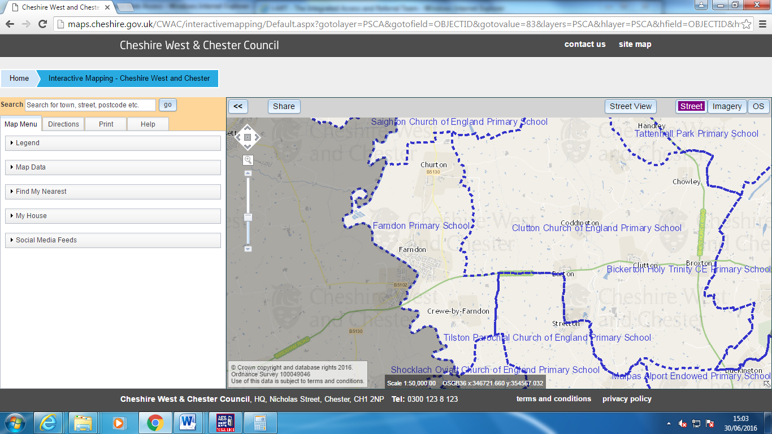

In year admission – applications can originate from

Application criteria for placement at school

- Looked or cared for children in placement
- To have a sibling already at the school
- To live and resident in the local area

Photo of School (Front elevation)
Entrance shown below is a vehicle entrance and car park.
The pedestrian entrance runs alongside the carpark and there is a fence to segregate pedestrians from vehicles.

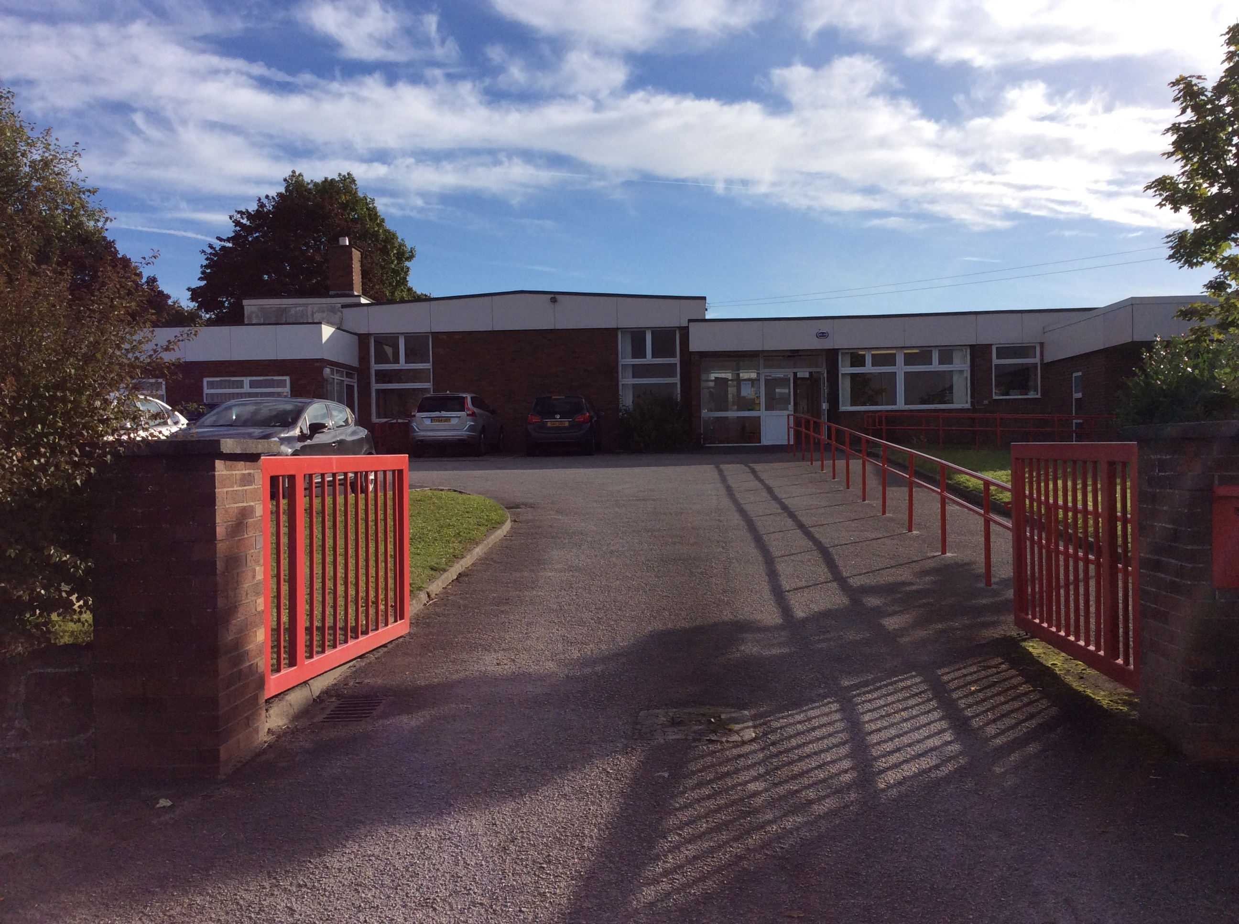

Photo of School (Rear elevation)

The school currently has 2 mobile classrooms that are away from the main building and do not have toilets. In respect of playgrounds, there is a difference in height. The first photograph shows the previous 2 classroom extension that replaced 2 mobiles.

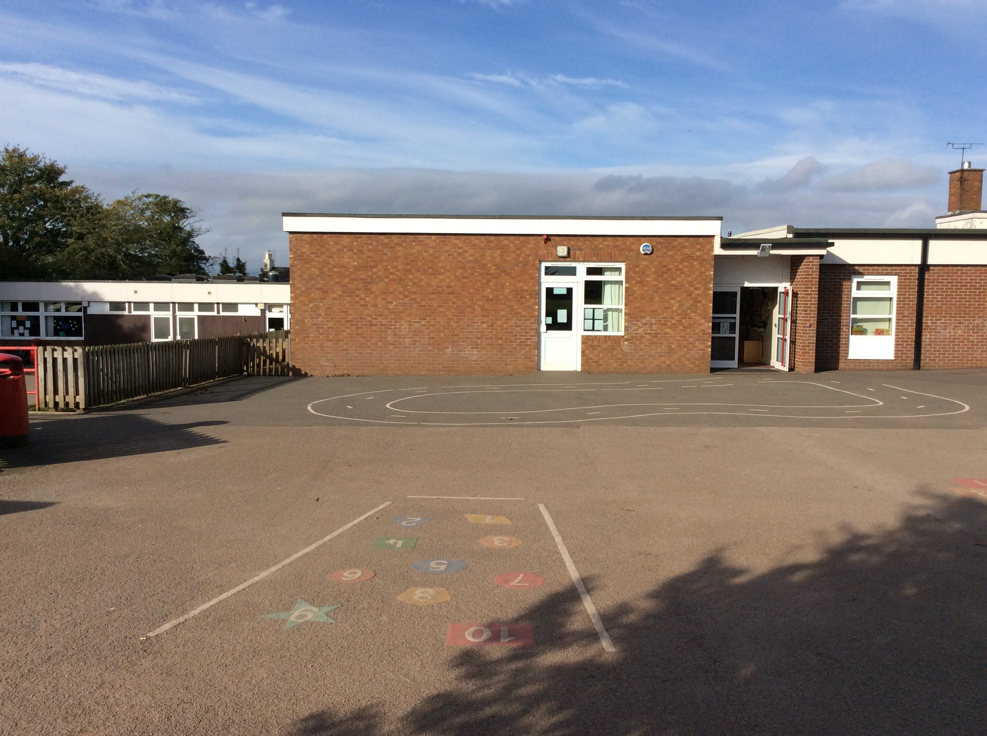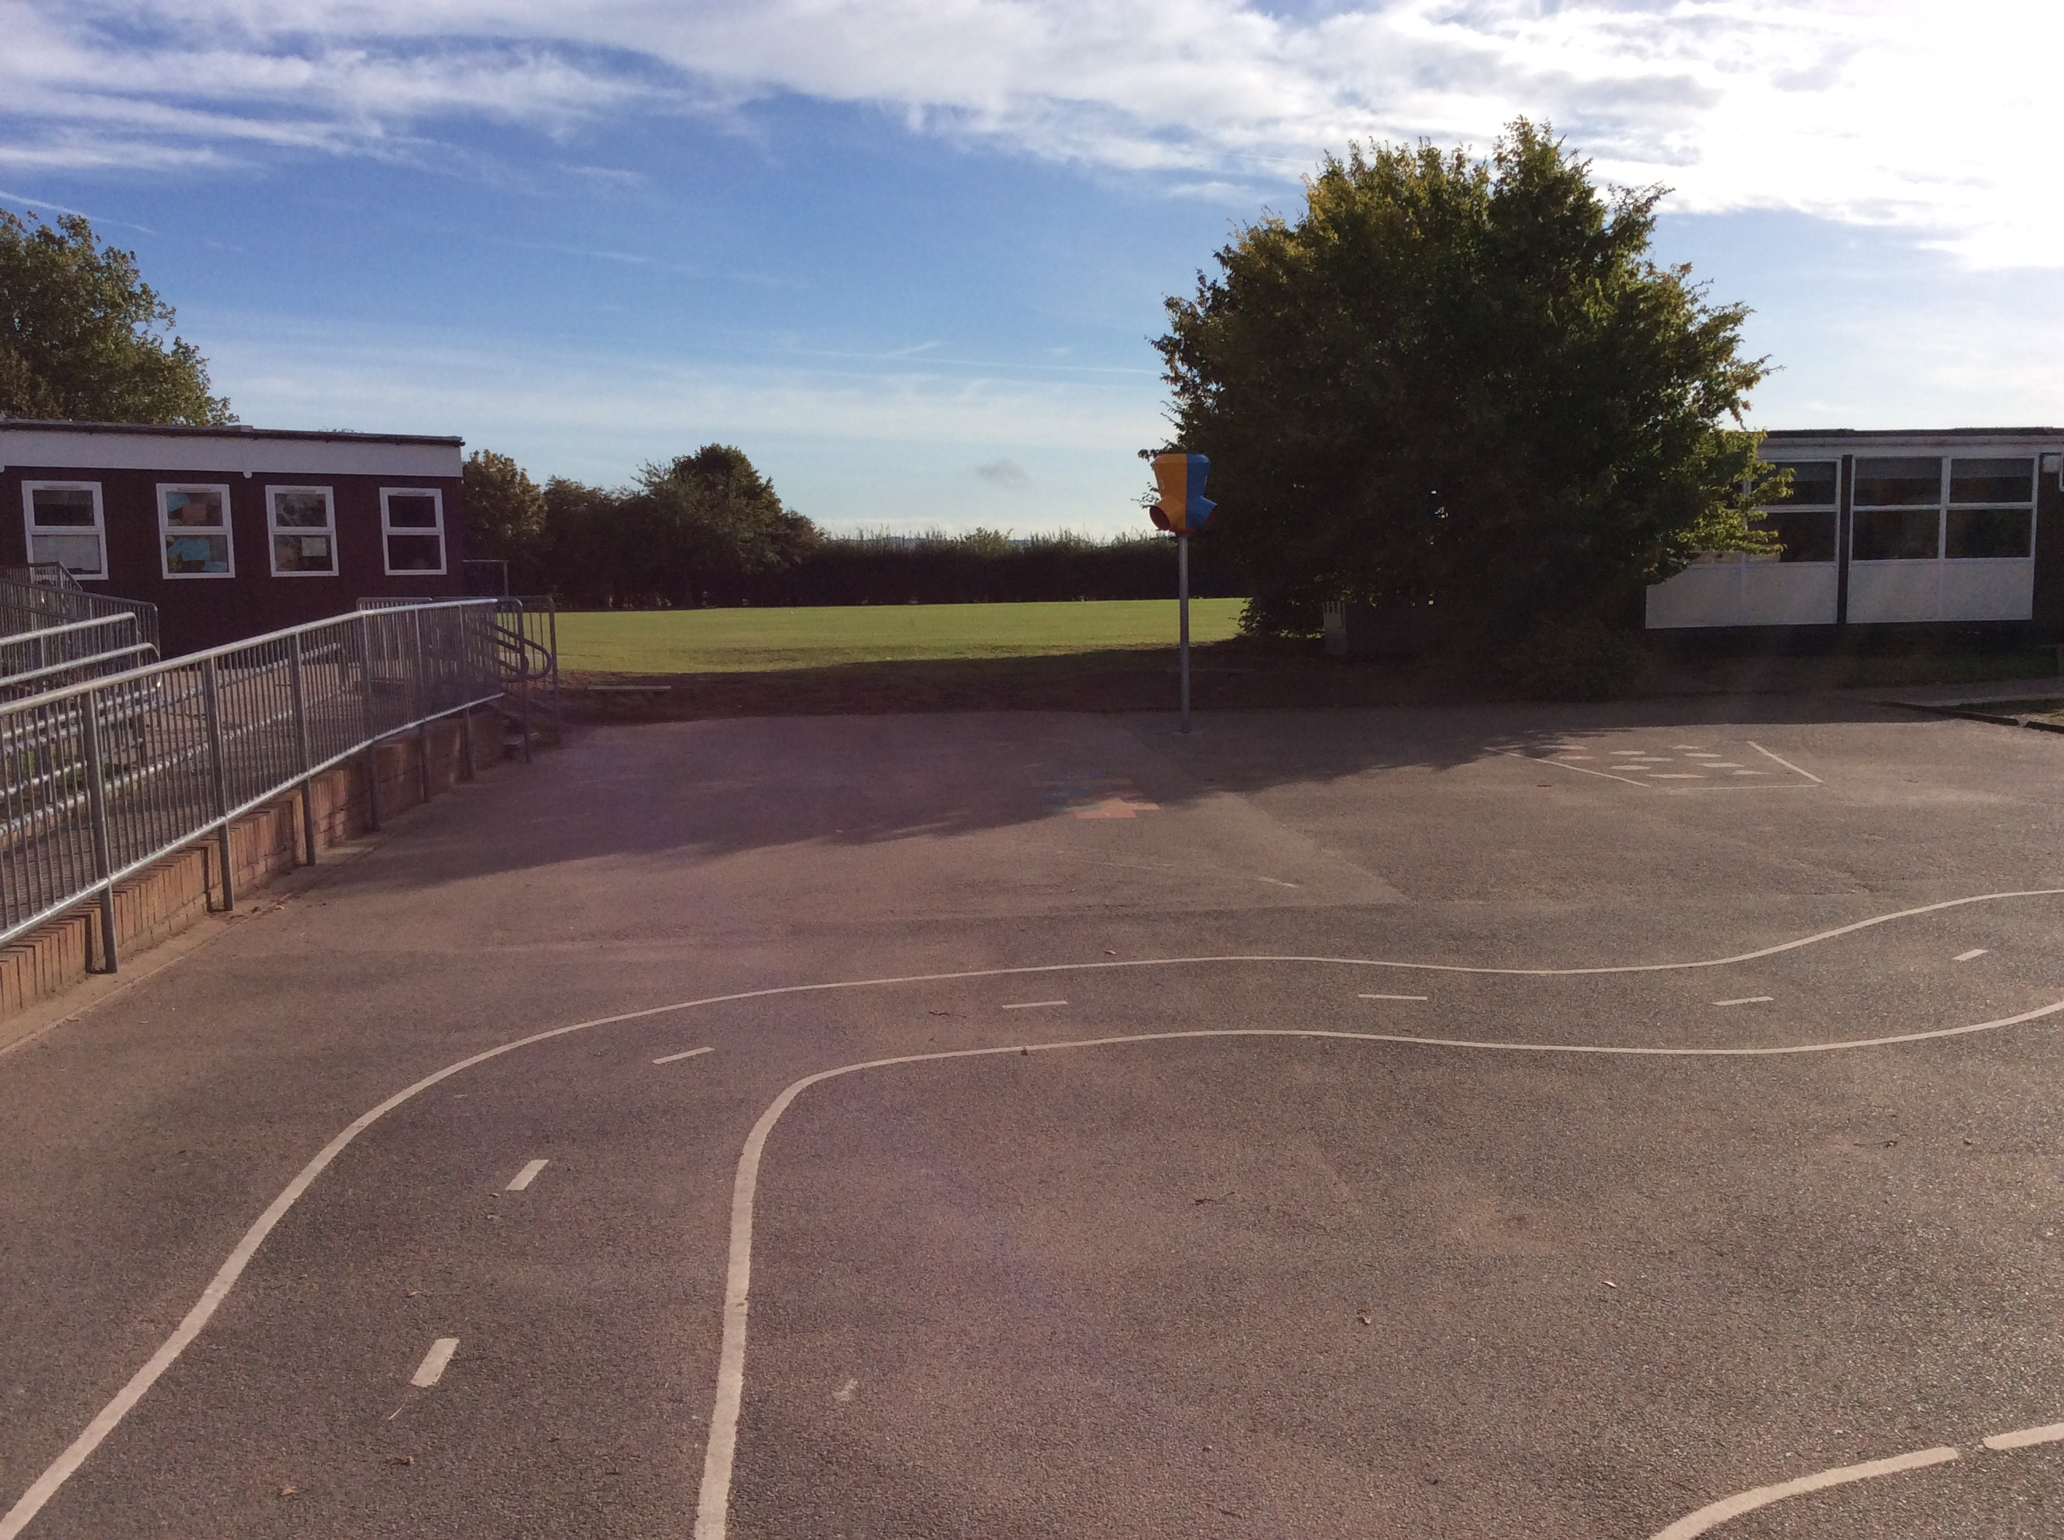

SCHOOL BUILDING AND GROUNDS

The school is surround by:

Housing on 3 sides and pasture land on 1 side (however, this land has planning permission).
There is one vehicle entrance and 2 pedestrian walkways into the grounds. One walkway is the main entrance and the other is the pupil entrance.

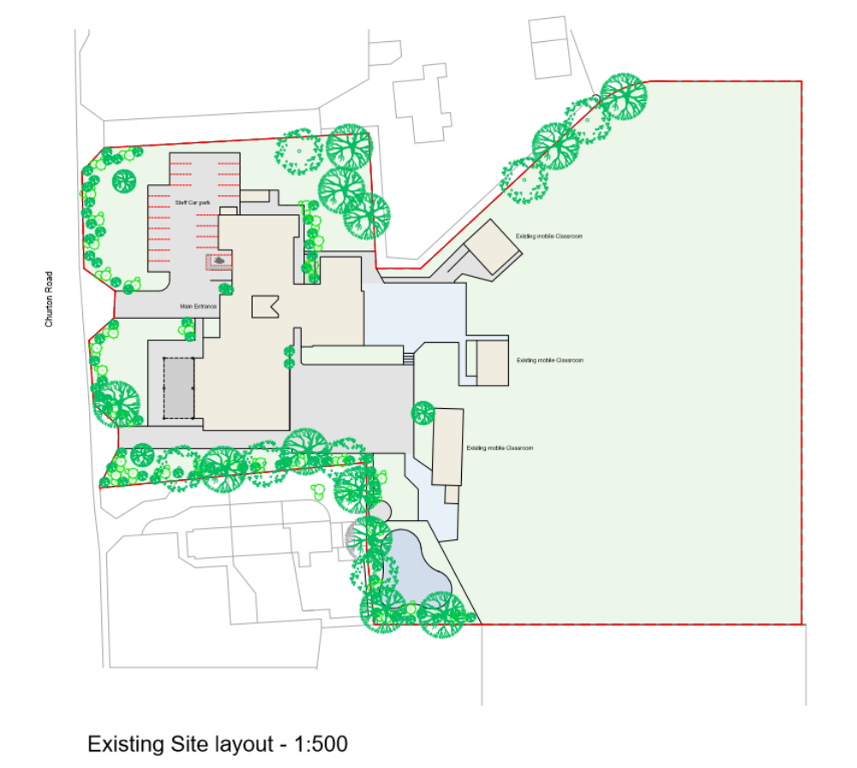
The proposed plan for the school potentially shows the redeveloped front entrance – developed into separate entrance and exit into the front turning circle and carpark.
It also shows the proposed extensions to front and rear of the school.

The centre of the village of Farndon can be approached by 3 routes; these are not main roads.

ROAD SAFETY CONCERNS

Summary of school’s transport and road safety concerns

CARS and ROADS
How many car parking spaces are there in total on your site? | 21
Do members your staff sometimes park outside the site due to lack of car parking spaces? | No: not since the car park was extended in Summer 2015.
Are parents allowed to park on site? | Not between the hours of 8:45 – 3:30. However, parents can use the car park to drop off and collect for Before and After School club. School did recent risk assessment and put in new pedestrian access and release after clubs down pupil entrance.
Where do visitors park? | In car park wherever possible but mainly have to park outside of the site.
Do you have disabled facilities? If not, how do you cater for these people? | One parking space outside main entrance, included in the 21 figure.
Do you have a separate entrance for pedestrians and/or cyclists? | There are two separate pedestrian entrances. Only one or two children bring cycles and they walk them through pedestrian entrances.
Do you run any school clubs which affect the parking situation? | Yes: Before and After School club. Dropping off in mornings can cause congestion.
What is the speed limit outside your school? Do cars adhere to this? | 30mph which reduces to 20mph when lights show.
Do you have any road markings outside your school (e.g. zigzags, double yellow lines)? Are these adhered to? | Zigzag lines are adhered to.Also, double yellow lines which can limit roadside parking for drop off / collection.
Is there a pedestrian crossing and/or school crossing patrol for your school? Where are they situated? | No
Are there any particularly dangerous roads near to the school? What makes them dangerous? (e.g. main road, high speed limit, narrow pavements etc) | The junction opposite the school is difficult at key times. There is only 1 pavement. Also, no pavements on certain sides of road that the school sits on.
Do you have any other problems concerning cars? | Double parking in Townfield Lane
CYCLING
Do you encourage cycling? If not, why not? | Yes but only two or three children participate. School does have a bike shed. It tends to be scooters.
Do you offer cycle training? | Yes Y6 in Autumn Term; Bikeability
Do you have a place to shower, change and store cycle gear? | No
How many formal cycle parking spaces do you have? Are these secure? | Bike shed could hold up to 10 bikes
How many of your cycle spaces are covered? | All of them
Is the cycle parking easily visible from the school? | Yes
Is cycle parking close to entrances used by the cyclists? | No. In Start and End of School day policy it states pupils have to walk with their bike.
Do you have a separate entrance for cyclists? | No it is the pedestrian access
Do you have any policies regarding cycling (e.g. pupils must wear helmets; pupils must be accompanied by an adult etc)? | Regular reminders in newsletters for bikes and scooters about helmets. Referenced in Start and End of School Policy.
Do you have any other problems regarding cycling? | Riding in playground when filled with parents and children. Reminded in newsletters and in start and end of school day policy.

SPECIAL EDUCATIONAL NEEDS
How many SEN pupils do you have, who have an element of travel to their statement? | None
How many vehicles transport SEN pupils to your school, and what type of vehicles are these (e.g. 2 taxis and 1 minibus)? | None
What arrangements are in place for picking up/setting down SEN pupils? | Some pupils on an EHC have pick up / drop off arrangements with staff at front entrance and so use the car park.
Do you have any issues/problems with SEN transport at your school? | N/A

Timetable of buses
There is one bus service available for Farndon Village – C56
They run nearly every hour. However, the last is at 17:17 and there is not later service. There is no shop/shopping facility in Farndon, apart from Dawsons DIY, Chadwicks newsagents, a butchers and Farndon chemist and post office. There is also a hairdressers and florist.
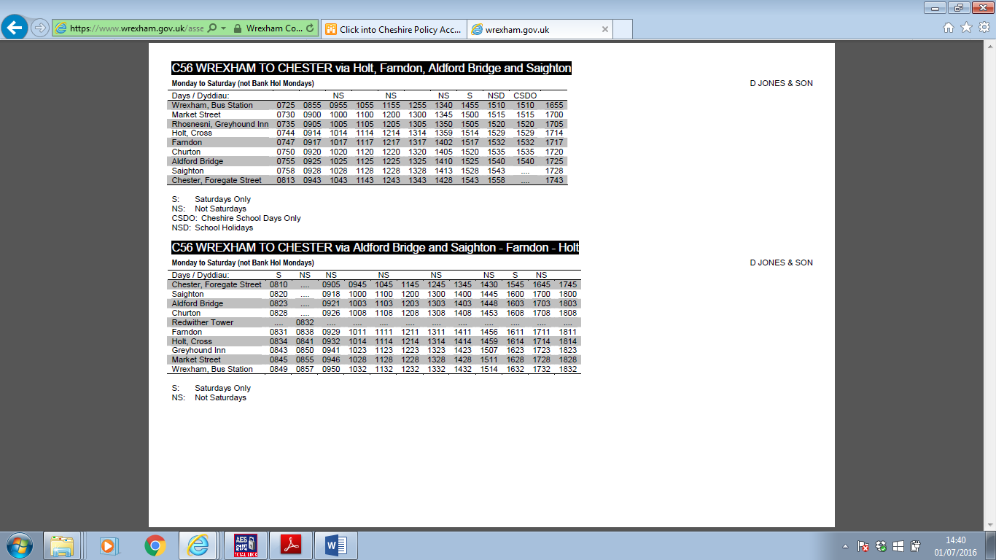

Demographics of the area the school supports

The school is situated in a small, rural village (2011 census recorded 740 dwellings) with extremely limited public transport.

There is a range of housing type – social housing to large detached properties with levels of affluence relative to cost of these properties.
The vast majority of parents at the school are in employment, with both parents working in many instances – the second income full or part time.
The village itself cannot sustain the school PAN and 73% of our children come from Farndon village. 17% of the school’s intake come from out of catchment and are from Wales as the school sits on the border. 7% are out of catchment within Cheshire West and 3% are in Chester (including surrounding areas).

Educational standards at Farndon Primary School are above average, which linked to a popular local High School mean the school attracts pupils from a wider area greater than its catchment area, particularly from Wales (See catchment area map).

The demographic of the school in terms of affluence is therefore mixed – whilst the school setting suggests an area of wealth, there is a range of socio-economic backgrounds evident making up the school population.

Pre school activities
Start | Finish | Type | Aim
7.45 | 8.45 | Breakfast club | Wrap-around care provision.  To look after children for parents to drop off early for school and provide children with a breakfast.

Normal school opening times are
Start | Finish | Type | Aim
8.55 | 3.30 | School | Normal school opening times

After school activities – All year
Start | Finish | Type | Aim
3.30 | 4.30 | Extra-Curric.Clubs | School run activities
3.30 | 6.00 | After school club | After school child care club

EXTRA-CURRICULAR CLUBS – Autumn Term 2016

DAY | TIME | ORGANISER | YEAR | CLUB
Monday | 12:30 – 1:05  3.30pm – 4.30pm  3:30pm – 4:40pm | Premier Sports  Premier Sports  Journey Man | Y5 – Y6  Max 20  Y3 - Y6  Max. 25  Y1 – Y2  Max 20 | Sport  Sport  Speech and Language
Tuesday

Wednesday | 12:30 – 1:05  3.30pm – 4.30pm  3:30pm – 4:40pm | Premier Sports  Premier Sports  Journey Man | Y3 – Y4  Max 20  Y1 – Y2  Max. 25  Y3 – Y6  Max 20 | Sport  Sport  Speech and Language
Thursday

Friday

Historical data

Number on roll – current and previous 5 years taken in January
The school PAN (Pupil Admissions Number) is currently 210 children.

Year | Number on roll
2010 | 176
2011 | 176
2012 | 167
2013 | 175
2014 | 178
2015 | 192
2016 (Sept) | 206

The school is currently running at an average of 17 requests for in year places per year, since 2013.
This is due mainly to relocation to the area with a small number of requests per year being from local moves from local schools.

Number of parking spaces available throughout the day for:

Type | Number of spaces | Available hours
Buses | 0 | N/a
Drop off zones | 0
Visitors car parking | 0
Staff car parking | 20 | Through school day
Cycles | 1 | Through school day
Disabled parking bays | 1 | Through school day

Our current travel issues (Pupils and Parents from questionnaire)
- Possible congestion outside of the school gate
- Lack of parking areas without double yellows or yellow zig zags at the front of the school and struggle to park.
- Cars parked on the pavements.
- Children use scooters and out of control on pavements.
- Barnsont Court junction too wide making it hard to judge cars coming in and out of car park.
- Cars parked in Swallowfields to drop children, leave no space for children to walk safely and have to walk around the cars.
- Gates in school don’t open early enough.
- School needs more access gates.
- Lack of parking spaces close to the school.
- Difficult to manoeuvre through parked / entering / exiting cars.

Issues (Staff)
- No relevant to need public transport available
- Use of car necessary both as home/school travel and workload of papers to take home every night - a vehicle needed.
- Working hours/responsibilities/finish times plus locations staff live in make it difficult to car share with other colleagues

Entrances into/ from School - two available currently
Main entrance
- Shared entrance for staff cars, pedestrian path and cycles/motorbikes.
- Delivery vehicles to Kitchen have limited access to side access to kitchen.

Footpath Entrance
- Entrance for Pedestrians only.

School Policies - current

Type of policy | Details
School Attendance policy | All children must allow sufficient time to travel by sustainable means to enable them to attend school on time for the start of lessons.
School Induction policy | When new pupils are looking to join our school, information about sustainable travel will be included in the school prospectus pack.

Sustainable training/ education undertaken in school

Type | Year group | Aim
Road Safety learning in Early Years with the PSCO | Rec | To promote driving at a safe speed in front of the school.
Cycle training provided by Bikeability | Yr. 5/6 | To promote cycling for 10 year olds and over, in readiness for secondary school
Road Safety Officers in Year 6 hold half termly assemblies and conduct competitions |  | In their assemblies their aim is to raise awareness of road safety at key points in year: halloween / winter etc. They share their work on the website.

Home to school journeys – Means of transport Sept 2016

Number on roll: 206 (Pupils)

Mode | R | Yr1 | Yr2 | Yr3 | Yr4 | Yr5 | Yr6
Walk | 55% | 48% | 55% | 59% | 71% | 55% | 72%
Car | 45% | 52% | 45% | 41% | 29% | 45% | 28%
Taxi | 0% | 0% | 0% | 0% | 0% | 0% | 0%
Bus | 0% | 0% | 0% | 0% | 0% | 0% | 0%

TOTALS - HOW CHILDREN TRAVEL TO/FROM SCHOOL Sept 2016

Means of travel | Taxi | Car | Walk | Bus | Total number
No. of children | 0 | 84 | 93 | 0 | 177
% | 0% | 47% | 53% | 0%
No. of car shares |  | 3 car shares
No. of parental cars expected each day |  | 43 cars expected each day

Family questionnaires
An extensive survey of parents and pupils was conducted in October 2016. It aimed to establish how they felt about their child's journey to school. It determined the areas of concern and what they expected to happen to alleviate these concerns. It was used as an opportunity to seek suggestions on how school travel could be improved. Some of the results are detailed below.

Surveys were distributed to all parents of the school. A 69% return was obtained from 147 families in the school (102 surveys were returned).

HOW FAR PUPILS LIVE FROM SCHOOL

- 47% of children live less than 1 mile from school
- 7% of children live between 1 – 2 miles from school
- 9% of children live between 2 – 3 miles from school
- 9% of children live between 3 – 5 miles from school
- 26% of children over 5 miles from school.
- 5% no response given.

The above chart shows that, understandably, the distance people live from school has an effect on the number of pupils who walk. 54% live less than 2 miles from the school and currently statistics show 53% of families walk.

Summary Results

The survey has proved very useful in producing this Travel Plan. Below is a summary of some of the key results.

How parents would choose how to travel to and from school

Mode of travel | Amount of responses
Walk to school | 62
Cycle to school | 5
School bus | 1
Bus | 1
Car | 7
Walk or car | 3
Walk or cycle | 2
Walk or bus | 1
No response given | 5

Reasons why parents use the car

 |  |  |  |  | Number of responses | Of responses given % result
The distance is too far to walk |  |  |  |  | 29 | 26%
The roads are not safe to cross |  |  |  |  | 7 | 6%
I take other children to other locations |  |  |  |  | 8 | 7%
It saves time |  |  |  |  | 12 | 11%
I drop off/pick up on the way to work |  |  |  |  | 33 | 29%
Bad weather |  |  |  |  | 11 | 10%
No response |  |  |  |  | 12 | 11%

Cycling
When asked if parents would be willing to allow their children to cycle to and from school, parents answered as follows as to why they would not be happy for their child to cycle.

No, because,
I live too far away | 19
I live too close | 9
I don't have a bike | 4
Too young | 40
It's not safe | 39
No response | 22

* 3 other comments why no to cycling: traffic too fast on Churton Road; road is too busy with bad
parking; bus shelter couldn’t accommodate a lot of bikes.

Walking:
When asked if parents would be willing to allow their children to walk to and from school, parents answered as follows:

Yes | No
39 | 36
Parents who said YES would like to see: Parents said NO because:

Yes, if |  | No, because,
Road safety education | 11 | I live too far away | 20
Walking bus | 15 | We have a busy road to cross | 14
Park and stride | 6 | There are no suitable walking routes | 7
Walk once a week | 7 | No safe manned crossing at school gate | 6
Rewards for walking | 2
A parent waiting area | 0

Walking Bus:
Parents were also asked about a possible Walking Bus Scheme at the school.

When asked if parents would let their children use the walking bus:

YES | NO | UNSURE
30 | 26 | 16

4 responses were unsure what this was. 30 gave no response. 1 parent expressed concern that on Barton road pavements were very narrow with large hedges and felt would have concerns over large number of children walking this route.

INITIATIVES

What is the school already doing?
The school is involved with the following road safety schemes:

- Junior Road Safety Officer Scheme
- Annual participation in National Walk to School Week
- Let’s Bike training scheme for Year 6
- Healthy Schools week where encourage healthy living and walking /cycling / scooter to school.
- School Council
- Regular visits from School Liaison Officer and other visitors, to talk to pupils about Road Safety and travelling to school

What facilities does the school already have?
The school has the following facilities:

- Zigzag lines outside of school
- Bike / Scooter shelter

Awareness Raising/Action Planning/Questionnaires etc.

As part of schools current position and future growth.

Awareness Raising

Solutions | Target Date
Hold regular assemblies about the journey to and from school, with good news stories and awards, if appropriate. | Throughout  2016 / 2017
Inform parents about the current and new demands on school, explaining that you would like all pupils to come to school, whenever possible, by walking, school bus or car share.  Newsletters, leaflets, information evenings, include in prospectus etc. | Throughout  2016 / 2017
Introduce Road Safety and Safer Journeys into the curriculum, with suitable resources from CWaC using the Road Safety Officers and inviting LA team to participate in assemblies. Formulate together Parking Charter for Parents and share on Road Safety page on website.  Posters, competitions, logos, leaflets etc. | Throughout  2016 / 2017
Notice boards in staff rooms informing staff of progress. | Throughout  2016 / 2017

Objective 1: To encourage more children to walk to school |  | Target 1: Increase to 75 % by June 2017
ACTION | TASKS |  | PERSON RESPONSIBLE | TIMESCALE
Launch the aim for more children to walk | - Involvement in Walk to School campaigns along with housing developers.  - Pedestrian training (e.g. Let’s Walk )  - Personal safety training and Road Safety Officers to lead whole assemblies  - Walking buddies  - Liaise with Parish Council for parking in village so parents can “ride and stride” |  | Head teacher  Lindsey Lancelotte | Summer term 2017
Set up a walking bus scheme | - Risk assess routes  - Recruit and train volunteers  - Trial period for 2 weeks |  | Lindsey Lancelotte | Summer 2017
Monitor and celebrate progress and successes | - Half termly assemblies where walkers are celebrated.  - Share and celebrate statistics on newsletters, twitter and school blogs. |  | Head teacher
Liaise with Housing developers for a path and entrance. | - Meet with Housing developers for them to possibly fund a path and gated entrance into school from the new estate. |  | Head teacher | Autumn 2016

Objective 2: To encourage more children to cycle to school safely |  | Target 2: To increase the number of children who cycle to school to 5% by June 2017
ACTION | TASKS |  | PERSON RESPONSIBLE | TIMESCALE
Survey to identify potential demand for cycling | - Given to all families |  | Headteacher | October 2016
Extend Let’s Bike training | - Ensure bikeability training takes place with Year 6  - Extend training to scooters using school’s PSCO and the Let’s Bike programme |  | Headteacher  Andrew Bond | October 2016
Ensure security of bikes | - All bikes to be locked in bike shed
Establish school cycle policy | - Draw up cycle to school policy and have agreed principles with children |  | School council (Rachel McCarthy) | November 2016
Cycle maintenance training / cycle workshop / puncture repair workshop | - Approach parent community to see if anyone can lead along with Mr Bond |  | Andrew Bond | Ongoing

Objective 3: To reduce numbers of cars driving into school car park |  | Target 3: To eliminate the number of parents / carers who use school car park when dropping off late children by June 2017
ACTION | TASKS |  | PERSON RESPONSIBLE | TIMESCALE
Inform parents of no use policy. | - Newsletter  - Personal approach  - Occasional staff “manning” the front gate. |  | Headteacher | October 2016
School to issue parking passes | - Where parents have accessibility issues or part of EHC, display parking pass on front fo car. |  | Suzanne Knight | October 2016
Monitor | - Admin office to keep record of miscreants |  | Suzanne Knight | October onwards

Objective 4: To reduce the numbers of cars driving to end of Park Street |  | Target 4: To decrease the number of cars using Townfield Lane as turning circle and parking area.
ACTION | TASKS |  | PERSON RESPONSIBLE | TIMESCALE
Inform parents of concerns | - Newsletter and letter |  | Headteacher | October 2016
PSCO to monitor and advise parents. | - School liaise with PSCO and share concerns with parking inappropriately in Townfields. PSCO visit site regularly at drop off / pick up and speak with parents as well as having visible presence. |  | Headteacher  Jonathon Hurst (PSCO) | Ongoing
Monitoring | - Ann Hughes / Andy Walker monitor when out at front gate with cones. |  | Headteacher | Ongoing

Questionnaire: For parents

1) Name of student ..................................... 2) Date .......................................

3) Class ................................ Year Group ..................................

4) Please detail any issues that affect travel to and from school and are there
any particular issues you may have, please expand on here?
……………………………………………………………………………………………………………………………………………………………………….
(Please use reverse if you require more space)

- In the morning, how do you usually get to school?*

BUS
WALK
CAR SHARE**
CYCLE

CAR/VAN

RAIL

OTHER(please state) ...............................

- After school, how do you travel home? *
OTHER(please state) ...............................
CYCLE
BUS
CAR/VAN

CAR SHARE**
RAIL

WALK

7) If you could choose how to travel to and from school, how would you like to travel ?

--------------------------------------------------------

* Where a pupil uses more than one mode please record the one which covers the greatest distance
** Car share is “travel in a car with another child/children also going to school but who does/does not live in the same house”

8) How far is it from home to work by the route you usually use?

Less than 1 mile £ 1-2 miles £ 2-3 miles £ 3-5 miles £

5 miles or over £
9) If you use your car, what are the reasons for this?

Distance is too far to walk Roads not safe to cross

It saves time I take other children to other locations

Bad weather I travel on to work

10) Would you be willing to allow your child to cycle to school?
If no, what are the reasons?

Live too far away Live too close

Don’t have a bike Safety; lack of cycle lanes

Too young; concerned Other

11) Would you consider allowing your child to walk school Yes No if……

Given road safety education Walking bus

Park and Stride scheme Walk once a week

Rewards for walking Covered parent waiting area

If you answered no, what are your possible reasons?

We live too far away Would have to cross busy roads

No suitable walk routes No safe “manned” crossing at school gate

12) Would you be interested in a walking bus? Yes No Unsure

Staff questionnaire

1. What is your home Postcode?

2. Job title……………………………………………………………………………………….

3. How far is it from home to work by the route you usually use?

Less than 1 mile £ 1-2 miles £ 2-3 miles £ 3-5 miles £

5 miles or over £

4. How do you usually travel to work?

Car all the way £ bicycle £ bus £ walking £

Train £ car and more than 5 minutes walk £ other £

5. How do you usually travel from work?

Car all the way £ bicycle £ bus £ walking £

Train £ car and more than 5 minutes walk £ other £

6. Do you car share with another adult that also works at your school?

Yes £ No £ No, but would consider £

7. a) What time do you usually arrive at school?.................................

b) What time do you usually leave school?......................................

8. If you could choose, how would you like to travel to and from work?

Walk £ car £ bus £ bicycle £ other £

9. Are there any improvements that you would like to see made to transport provision that would encourage you to cycle, walk, use public transport or car-share?

Within the school site £ Comments…………………………………………………………

Outside the school site £ Comments………………………………………………………

10.Are there any issues regarding pupil/staff safety that you would like to raise?

Farndon Primary School

September 2016

