Junior

Safety

Officers

GREEN CROSS CODE
- Stop: First find a safe place to cross.

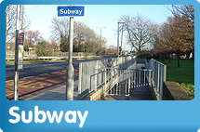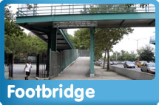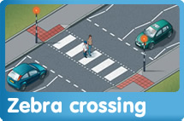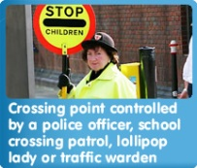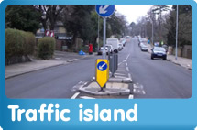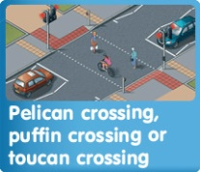

NEVER cross:
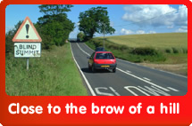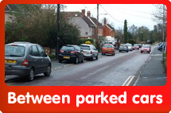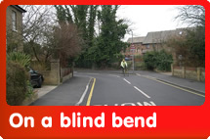

- Look: It’s important that you can see all around you clearly in all directions. If you can’t see traffic then the traffic can’t see you. Look all around you for traffic. LOOK right, then left and then to your right again before you cross.

4. Listen: You can usually hear traffic. Listen carefully for traffic that you can’t see. Beware of electric cars and other vehicles that don’t make a sound such as scoots and bicycles.

5. Think: You have done this at every stage. When it is safe and there is no traffic, walk straight across the road. Keep looking and listening while you cross the road.
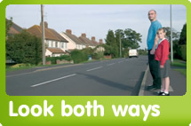
NEVER run across the road because you might fall over and you might not get up in time.
Look and keep looking while you cross the road.

